Canberra Health Services
Procedure
Respiratory Protective Program

Contents

Canberra Health Services 1
Contents 1
Purpose 3
Scope 3
Section 1 – Responsibilities 4
Section 2 – Respirator use within CHS 5
Section 3 – Inclusion and Exclusion Criteria for Fit Testing 7
Section 4 – Accessing Fit Testing 9
Section 5 – Fit Testing 10
Section 4 – Cleaning and Disinfection of Respirator Fit Test Equipment and Accessories 17
Section 5 – Fit Checking 18
Section 4 – Storage, Maintenance and Care of Respirators 20
Evaluation 21
Related Policies, Procedures, Guidelines and Legislation 21
References 22
Search Terms 22
Attachments 22
Attachment 1 - Respiratory Assignments by task or location 24
Attachment 2 – Risk Assessment - Respiratory Assignments by task or location 25
Attachment 3 – Information Sheet: Fit Testing 26
Attachment 4 – Competency Assessment 27
Attachment 5 – Fit Testing Checklist 28
Attachment 6 - Canberra Health Services (CHS) Respiratory Protection Program Fit Testing Information Sheet 29
Attachment 7 – Respirator Fit Testing Card 31
Attachment 8 Staff Fit Test Information and Results 32
Attachment 9 – Fit Testing Process Flow 33

Purpose
The purpose of this procedure is to describe Canberra Health Services (CHS) Respiratory Protection Program (RPP) and inform workers how to access the RPP.
CHS has an obligation under the Work Health and Safety (WHS) Act 2011 to provide a safe and healthy environment for all CHS workers, volunteers, patients, contractors (and their workers), as well as visitors to the hospital facilities, sites and community service areas under our management.
The WHS Act 2011 requires CHS to manage health and safety risks. This is achieved by the elimination where reasonably practicable, and where elimination is not practicable minimisation of risks .
With the emergence of global infectious diseases such as COVID-19 and Severe Acute Respiratory Syndrome (SARS), there is a heightened awareness of the need for workers to be able to work safely and be protected against the exposure to respiratory pathogens.
Certain work groups are not likely to be exposed to infectious respiratory pathogens, but may be exposed to other hazardous substances, and require respiratory protective equipment for this aspect of their work.
The development of a Respiratory Protection Program (RPP) in line with NSW Clinical Excellence Commission (CEC) guidelines allows for CHS to provide this level of protection for its workforce.

Back to Table of Contents

Scope
This procedure applies to any CHS workers, clinical and non-clinical, who may be exposed to airborne pathogens while performing their required duties and are required to wear a respirator. It applies to the use of disposable filtering face piece respirators (N95/P2 masks).
This procedure does not apply to surgical masks or reusable air-purifying and air-supplying respirators.
The use of respiratory protection by contractors working on CHS sites will be managed by CHS Contractor Management procedures. However, it remains the responsibility of the Contractor to ensure the appropriate respiratory protection is provided to workers, is worn and is suitable for the work to be performed.

For the purposes of this procedure the term:
- fit testing refers to Quantitative Fit Testing.
- respirator refers to N95/P2 respirator mask
Back to Table of Contents

Section 1 – Responsibilities

Employees must:
- Declare any medical reason that means they cannot be fit test/or wear Respiratory Protective Equipment (RPE)
- Have only approved facial hair styles (Refer to Infection Prevention and Control – Healthcare Associated Infection Procedure)
- Attend respirator fit testing as required
- Use, maintain, and dispose of respirators properly in accordance with training and local procedures
- Conduct a fit check of a respirator, every time one is used.

Supervisors/line managers must:
- Ensure that all potential exposures to respiratory hazards, including exposure to chemicals and aerosol transmissible pathogens, have been identified and workers have been provided with the correct RPE
- Ensure that workers who require RPE are identified
- Ensure that this procedure is implemented in the work area
- Ensure workers attend the required training and scheduled fit testing
- Ensure that records of respirator training are documented and available.

Unit Managers must:
- Ensure this procedure is implemented within their areas
- Ensure that hazards / risks are identified and managed in consultation with their workers and work areas
- Ensure Risk Assessments are undertaken across their work areas to identify workers who require respiratory protection (refer to Attachment 1 & 2)
- Ensure that training and resources are available to allow compliance with this procedure.

Executives must:
- Ensure that a process is in place to allow the RPP to be implemented
- Ensure that all required resources are available for the implementation and ongoing management of the RPP.

Clinical Nurse Consultant Occupational Medicine Unit (CNC OMU):
- Coordinate fit testing schedule and confirm release of fit test assessors
- Coordinate training for fit test assessors
- Ensure competency assessment of fit test assessors is completed annually
- Maintain records relating to fit testing
- Coordinate scheduling of fit testing for new workers
- Maintain fit testing equipment and consumables related to fit testing
- Provide reports on fit testing results to CHECC, Work Health Safety, Divisional Executive Director and Standard 3 Preventing and Controlling Healthcare Associated Infections.

CHS Procurement must ensure:
- There is a sustainable supply of suitable respirators that meet the requirements of ACT Health and CHS workers.
- Respirators stocked at CHS meets WHS legislative requirements.
- Respirators stocked at CHS meet CHS Infection Prevention and Control policies and procedures requirements.

Back to Table of Contents

Section 2 – Respirator use within CHS

Equipment

Disposable Respiratory Equipment
Disposable respiratory equipment are N95/P2 respirator masks. These are preferred method of respirator protection at CHS.
Disposable respirators found to be defective are to be discarded and replaced. If this occurs, advice is to be provided to the relevant line manager who may need to advise CHS Procurement of the defect through the current communication protocols.

Voluntary Use of Respirators
When the use of a respirator is not required and a risk assessment has determined that its use is not necessary, a worker may still request to use a respirator voluntarily. The final decision will be made by the manager following their consideration of the individual circumstances of the request. Workers using respirators voluntarily will be included in the RPP.

Environments

Clinical Environments
The most common potential exposure for workers involved in patient care will be pathogens associated with aerosol transmissible diseases such as tuberculosis, measles, and chicken pox (Refer Infection Prevention and Control - Healthcare Associated Infection Procedure).
Infection Prevention and Control Unit (IPCU) will provide guidance regarding the type of RPE that would be suitable for workers in these environments, and this will be based on existing CHS Infection Prevention and Control practices and other relevant public health guidelines.

Other Environments
CHS workers within maintenance, housekeeping, laboratory, or other areas may potentially be exposed to hazardous gases, vapours, or dusts in addition to aerosol transmissible pathogens. A risk assessment is required that will identify and determine the type of RPE that is required for workers working in these environments. The risk assessment must be done in consultation with the workers in each of these environments.
The risk assessment will include the following:
- Identification of potential exposures.
- The duration of the potential exposure.
- A review of work processes to determine levels of potential exposure for all tasks and locations.
- Quantification or objective determination of potential exposure levels, where possible.
The supervisor/line manager will review and update the risk assessment any time a worker or supervisor identifies or anticipates a new exposure or changes to existing exposures occurs as a result of any changes to practice or operating conditions.
Any worker who believes that RPE is needed during a particular activity must contact their line manager. The line manager will assess the potential risks with the worker(s). If it is determined that respiratory protection is required, the line manager will liaise with the CNC OMU to make an appointment for a fit test. The worker will be directed to attend a fit test.

Section 3 – Inclusion and Exclusion Criteria for Fit Testing

Workers whose work activities require the use of a respirator must be physically and psychologically fit to participate in the fit testing program and the wearing of the respirator.
Workers should be assessed regarding the appropriateness of working in clinical environments with increased potential of exposure to infectious airborne pathogens and performing aerosolizing generating procedures.

CHS has developed priority groups of workers who require fit testing to ensure workers with the highest risk are prioritised for fit testing.
Priority | Worker Category | Clinical Areas
1 | Caring for COVID Positive patients | Staff performing or assisting in procedures such as BVM ventilation, intubation, LMA insertion, surgical airway emergency ENT procedures, bronchoscopy, etc
2 | Caring for Inpatient’s with Suspected COVID (e.g. red zones) | Staff perform or assist in BVM ventilation, intubation/LMA insertion, suction, bronchoscopy
3 | Caring for confirmed COVID positive inpatient care | Staff managing patients on NIV, CPAP, BiPAP, requiring suction, HFNP
4 | Caring for inpatient’s suspected COVID positive (consistent with red zone requirements – symptomatic with epidemiologic links) | NIV, CPAP, BiPAP, suction, HFNP
5 | Confirmed or suspected COVID inpatient care | Within care environment of patient undergoing procedures listed in priority round 1-4
6 | Undifferentiated patient care | Areas where a clinical risk assessment is still to be undertaken e.g. emergency departments - NIV, CPAP, BiPAP, suction, HFNP
7 | COVID testing facilities or high risk patient respiratory swabs outside of testing facilities | E.g. Deep nasopharyngeal and throat swabs, For general wards please identify staff that have already been fit tested to provide swab procedures and if not enough capacity send through extra select staff for fit testing
8 | Other clinical staff | Other lower risk/semi-elective AGPs
9 | Other clinical staff | No AGPs

Workers who do not require fit testing:
- Administration staff who are not working in a clinical environment, e.g.Divisional Executive Offices.

Workers who have completed fit testing can be retested if there is:
- A change in PPE they wear
- No supply or discontinuation of workers preferred respirator and at fit testing no other respirators where identified as also suitable.
- Physical changes that could affect respirator fit. These changes include, but are not limited to, facial scarring, dental changes, cosmetic surgery, or an obvious change in body weight/face shape or facial hair.

Workers who are unable to use respirators
Workers who may be unable to use respirators are:
- Aged older than 65 years of age.
- Pregnant.
- Significantly immunosuppressed.
- Diagnosed with a chronic heart or lung diseases or have active solid organ cancer.

Anyone over the age of 65 may not be permitted to work in areas with a potentially higher risk of exposure as they may have other risk factors. The suitability of workers aged over 65 years to work in areas of potentially higher risk is a decision based on an informed discussion between the worker and their treating doctor, with a recommendation made on a case by case basis.
Workers who are pregnant, significantly immunocompromised, have a chronic heart or lung condition or have a solid organ cancer should have an informed discussion with their doctor on whether they choose to work in areas with a potentially higher risk of exposure.
It is the workers responsibility to provide a written statement to their manager on their decision to be placed or rostered in these environments following the discussion with their doctor.
The information included in the medical statement should include the following:
- If the worker is able or unable to participate in the fit testing program due to medical reasons.
- The medical signs or symptoms the worker reports that are related to the ability to use a respirator.
- That a medical evaluation of the worker has been completed.
- Outcome of medical evaluation.
If a worker is unable to participate in the fit testing program for medical reasons, the manager is to complete a Staff Incident report within the CHS reporting tool, RiskMan.
Workers who fail fit testing or are unable to wear respirator

Options for staff who are unable to find a suitable respirator or are unsuitable to wear a respirator but are required to wear a respirator for their role include:
- Utilising a risk management approach to ensure that the worker is not exposed to any situation in which a respirator would be required.
- Relocating worker to another work area where respirator use is not required in carrying out normal work tasks for that area.
- Using a risk management approach to determine if the worker can continue working in areas with a potentially higher risk of exposure, if requested by the worker. If appropriate risk controls are identified and the worker still wishes to continue working they must provide a written statement to their manager confirming this.

Back to Table of Contents

Section 4 – Accessing Fit Testing

The worker is to bring any special/specific PPE they wear at work (e.g. glasses, earplugs, hardhat) to the testing appointment so they can be worn during testing.

New workers who are eligible will be fit tested through the Occupational Medicine Unit (OMU) onboarding process. Recruitment staff are to send details of new workers to OMU via CHS.FitTesting@act.gov.au. New workers who will work in areas managing COVID positive patients will be fit tested prior to commencing work, or prioritised ASAP. New workers will be classified as per priority list below and the worker contacted when an appointment is available for them.

Accessing fit testing
- Manager of area to assess which staff members require fit testing.
- Manager to send list of staff to Divisional Executive Director for approval.
- Approved list sent by Divisional Executive Officer to CHS.FitTesting@act.gov.au
- OMU staff assess the staff’s urgency for fit testing based on the following:
- First priority - Staff working in clinical area managing COVID positive patients
- Second priority - Staff who may come into contact with COVID positive patients and be exposed to aerosoling procedures – Birthing, Anaesthetics, Gastroenterology and Hepatic Unit, Testing sites, Community staff
- Third priority – All other CHS staff
- OMU books appointment and contacts worker with date/time and information regarding testing.

Section 5 – Fit Testing
CHS will undertake fit testing as part of its ongoing RPP.
Training:
Fit testing shall be carried out by staff that have been trained and assessed as competent to:
- Calibrate the equipment and ensure it is in proper working order
- Perform the fit test to meet ISO 16975-3 Respiratory Protective Devices Fit Testing Procedures requirements
- Recognise invalid tests
- Calculate fit factors
Refer to Attachment 4 for competency assessment.
A facial seal cannot be achieved if the worker has facial hair that lies along the sealing area of the respirator. All workers being fit tested are recommended to be clean shaven or have facial hairstyles in line with Infection Prevention and Control – Healthcare Associated Infection Procedure and Figure 1 below.

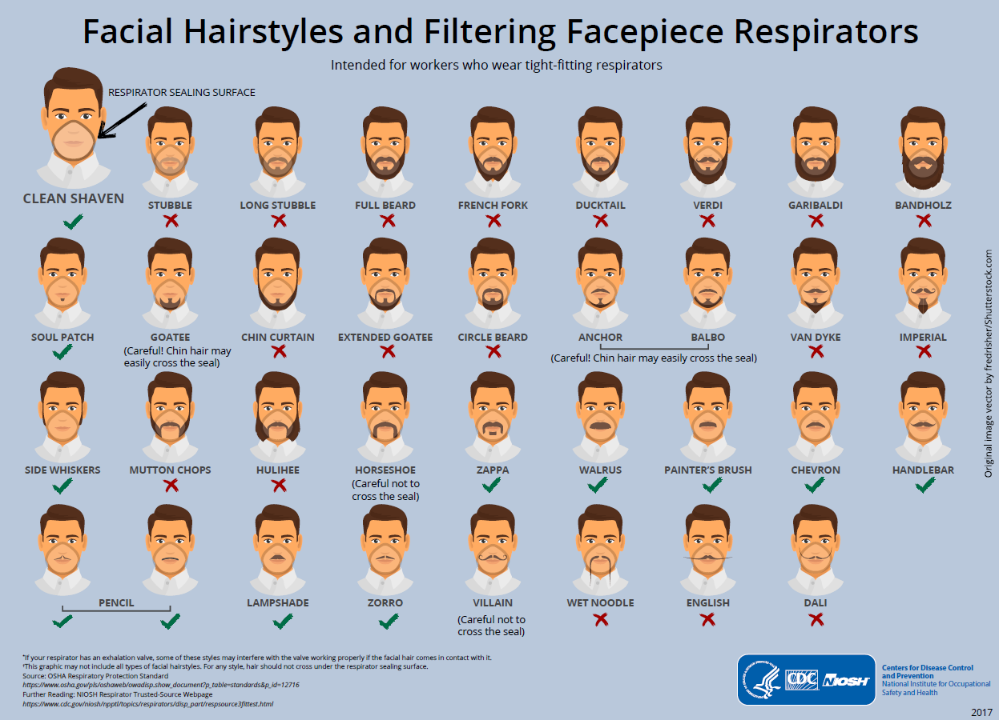
Figure 1: Facial Hairstyles and Filtering Facepiece Respirators Centres for Disease Control and Prevention 2017

Fit Testing Procedure .
Refer to Attachment 5 Fit Test Checklist for a quick guide of the steps to completing fit testing.

Fit testing must be undertaken in an appropriate environment (e.g., clean, non-cluttered room with access to power)

The worker will be offered a selection of several models and sizes of respirators that are readily available in their work area.

Note: The worker is to be instructed to inform the fit test assessor at any time during the initial fit check if the respirator is uncomfortable.

Initial fit check:
- The worker is shown how to put on the respirator, how it should be positioned on the face, how to set strap tension and how to determine an acceptable fit. A mirror/smart phone with mirror app is to be available to assist the worker in evaluating the fit and positioning of the respirator. This instruction does not constitute training on respirator use.
- The worker dons the respirator and assesses the comfort. If the worker is not familiar with using the particular respirator, they should be directed to don the respirator several times and to adjust the straps each time, to become adept at setting proper tension on the straps.
- The worker wears the respirator for approximately 5 minutes and assesses the comfort and fit as per step 4 and 5.
- Assessment of comfort shall include a review of the following points with the worker and allowing them adequate time to determine the comfort of the respirator:
- Position of the mask on the nose
- Room for eye protection
- Room to talk
- Position of mask on face and cheeks

The following criteria shall be used to help determine the adequacy of the respirator fit:
- Chin properly placed
- Adequate strap tension, not overly tightened
- Fit across nose bridge
- Respirator of proper size to span distance from nose to chin
- Tendency of respirator to slip
- Self-observation in mirror to evaluate fit and respirator position.
- The worker is instructed to seal the respirator on the face by moving the head from side-to-side and up and down slowly while taking in a few slow deep breaths the worker is then instructed to conduct a fit check by using either the negative and positive pressure seal (huff and puff) checks or those recommended by the respirator manufacturer.

Note: Fit test shall not be conducted if there is any hair growth between the skin and the respirator sealing surface, such as stubble beard growth, beard, moustache, or sideburns which cross the respirator sealing surface. Any type of apparel which interferes with a satisfactory fit shall be altered or removed.
The worker will be fit tested following the process outlined below for each mask readily available within their work area.
Workers who wear corrective glasses or other PPE must wear these during their fit testing to ensure they do not interfere with the face piece seal, and that the respirator does not interfere with their visual field.
Alert: If at any time the worker becomes short of breath, dizzy or uncomfortable during fit testing, the test shall stop.

Note: If the worker finds the fit of the respirator unacceptable/uncomfortable during the fit test, the worker shall be given the opportunity to select a different respirator (if available) and to be retested.
Procedure:
- Prior to the first test of the day the fit test device is to be wiped with a neutral detergent and disinfectant wipe (2-step process or a dual-purpose wipe 1-step process). Refer to Section 4 for more information.
- Fit test assessor to set up Device (PortaCount™ or AccuFit™) and Particle Generator as per manufacturer’s instructions for use.
- Perform hand hygiene.
- Start the particle generator for 10 minutes before starting fit testing. For:
- PortaCount add 1 salt tablet and water
- AccuFit only use plain water
- Place the particle generator 1.8-2m away from the Device.
- Ensure that the surface around the Device and particle generator are clear.
- Install the twin tubes – blue to blue, clear to clear, attach HEPA filter to clear tube.
- Confirm alcohol is visible in the alcohol cartridge.
- Install alcohol cartridge into the Device (make sure it is not turned on).
- Turn on the Device.
- Connect the Device to the laptop.
- Conduct the Device daily check making sure half face mask settings (N95/P2 option) is selected. Ensure pass score is set at over 100.
- Prior to the commencement of the fit test, the fit tester assessor explains the fit test process to worker and gives them the CHS Fit Testing Information Sheet, Attachment 6, and asked to confirm they are physically and psychologically well and are happy to proceed with the test.
- The worker is instructed to tell the tester if they experience any difficulty in breathing during the tests to ask for the test to stop. Workers who are unable to complete the fit test due to breathing difficulties are referred to their General Practitioner (GP) or other health care professional to determine whether the worker can wear a respirator while performing their duties.
- Worker and fit test assessor to perform hand hygiene.
- The worker applies the respirator (without assistance from the fit test assessor) and any applicable safety equipment that may be worn during actual respirator use which may interfere with respirator fit.
- Fit test assessor notes the time. The respirator must be worn for approximately 5 minutes prior to testing to purge the ambient particles trapped inside the respirator and confirm comfort check of the selected respirator.
- Worker to demonstrate a fit check (as per process outlined above) including confirmation of seal (negative/positive pressure test) with fit test assessor observing before proceeding to fit test.
Note: The worker is not to touch the respirator during the test after placing it on their face.

- Fit test assessor:
- Enters workers details and allocate the correct respirator style and size into the software.
- Select OSHA modified protocol.
- Commence fit test.
- Participant to hold the tubing during fit test.
- Fit test assessor to insert the probe into the respirator.
- The laptop displaying the instructions for the worker is turned to face the worker. The worker is asked to follow the instructions as displayed. Fit testing will consist of the following exercises:
- Normal breathing. In a normal standing position, without talking, the worker shall breathe normally.
- Deep breathing. In a normal standing position, the worker shall breathe slowly and deeply, taking caution so as not to hyperventilate.
- Turning head side to side. Standing in place, the worker shall slowly turn his/her head from side to side between the extreme positions on each side. The head shall be held at each extreme momentarily so the worker can inhale at each side.
- Moving head up and down. Standing in place, the worker shall slowly move his/her head up and down. The worker shall be instructed to inhale in the up position (i.e. when looking toward the ceiling).
- Talking. The worker shall talk out loud slowly and loud enough so as to be heard clearly by the fit test assessor. The worker can read from a prepared text such as the “The Rainbow Passage” count backward from 100 or recite a memorized poem or song.
The Rainbow Passage
When sunlight strikes raindrops in the air, they act like a prism and form a rainbow. The rainbow is a division of white light into many beautiful colours. These take the shape of a long round arch, with its path high above, and its two ends apparently beyond the horizon. There is, according to legend, a boiling pot of gold at one end. People look but no one ever finds it. When a man looks for something beyond his reach, his friends say he is looking for the pot of gold at the end of the rainbow.
- Grimace. The worker shall grimace by smiling or frowning.
- Bending over. The worker shall bend at the waist as if he/she were to touch his/her toes.
- Normal breathing. Same as exercise (1).
- Each test exercise shall be performed for one minute except for the grimace exercise which shall be performed for 15 seconds. The worker will be questioned by the fit test assessor regarding the comfort of the respirator upon completion of the protocol. If it has become unacceptable, another model of respirator should be tried.
- The respirator must not be adjusted once the fit test exercises begin. Any adjustment voids the test, and the fit test must be repeated.
- The PortaCount will automatically stop and calculate the overall fit factor for the entire set of exercises. The overall fit factor is what counts. The Pass or Fail message will indicate whether or not the test was successful. If the test was a Pass, the fit test is over. This is repeated for each mask that the worker is tested on.
- Fit test assessor confirms with worker the respirator is still comfortable and informs them if it was positive (confirmed good fit) or negative (not a good fit). Results of fit test documented with name of worker, overall fit factor, make, model, style and size of respirator used and date tested will be entered into the worker’s profile in Riskman.
- Worker:
- Doff respirator correctly – if not done correctly, fit test assessor to demonstrate/instruct correct technique.
- Remove the twin tube from respirator probe.
- Dispose of used respirator into clinical waste.
- Perform hand hygiene.
- Fit test assessor to remove the tubing from the respirator probe and perform hand hygiene.
- If respirator was comfortable and a positive test result document on the Fit Testing Card, see Attachment 7.
- Assessor to disconnect the twin tubing from the Device and wipe with neutral detergent and disinfectant wipe (2-step process or a dual-purpose wipe1-step process).
- Assessor to perform hand hygiene.
- If a pass has been achieved for a respirator, provide worker with a Fit Testing Card indicating which respirators passed, Attachment 7, and Worker Fit Test Information and results handout, Attachment 8.
- When testing is complete empty particle generator:
- PortaCount - run plain water for 2 minutes, wipe external parts, dry and store.
- AccuFit – dry the internal canister by wiping with a paper towel and store.
- At the end of the day the Device and accessories are to be cleaned, packed in provided case and stored. Refer to Section 4 for more information.
Note: The overall fit factor is the most important data item. It is the overall result of the fit test and usually the only fit factor value that must be retained as part of the record keeping. The fit factors for the individual exercises are not as important. It is possible to have a passing overall fit factor even though one of the exercises resulted ina failing fit factor. The overall fit factor is a weighted average related to the amount of airborne hazard that the person might have inhaled if the worker were in the workplace. Fit Factor numeric values so clost to the Pass/Fail Criteria would always be investigated and remedial training or reseltction of the RPE should be instigated.

Workers Who Fail a Fit Test
If a respirator that is comfortable and passes the fit test can not be found for the worker from the available CHS stock, the OMU CNC will notify the relevant manager. The manager will be advised of the following options to ensure that the worker remains safe:
- Use a risk management approach to ensure that the worker is not exposed to any situation in which a respirator would be required .
- Relocate worker to another work area where respirator use is not required in carrying out normal work tasks for that area.
- Using a risk management approach to determine if the worker can continue working in areas with a potentially higher risk of exposure, if requested by the worker. If appropriate risk controls are identified and the worker still wishes to continue working they must provide a written statement to their manager confirming this.

Refer to Attachment 9 Fit Testing Process Flowchart for an overview of the process.

Back to Table of Contents

Section 4 – Cleaning and Disinfection of Respirator Fit Test Equipment and Accessories
Fit Test Equipment
The disposable respirator fit testing process using quantitative fit testing with the PortaCount® or AccuFit® machine requires a single use adaptor (probes and nuts), and a reusable narrow twin tube connected to the inside of the respirator. The external part of the reusable twin tube must be cleaned between every subject and the internal part of the tube must be cleaned daily or as per the manufacturer’s recommendations. The internal part of the fit tester machine is self-cleaning. All outer surfaces are to be cleaned and disinfected in between uses according to the manufacturer’s recommendations.

The PortaCount® respirator fit tester has two internal HEPA filters which filter the air sample inside the instrument before being exhausted to the ambient air. After multiple uses moisture may develop inside the twin tube and in the alcohol cartridge due to condensation and high humidity in the area. Soaking and purging of water through the twin tubes may result in moisture accumulation, contamination of respirator fit tester with droplets, resulting in fit test fail. The alcohol cartridge and twin tubes must be dried properly before use.

Cleaning and disinfection of the interior of the twin tubes is not recommended to prevent damage to the respirator fit tester and the tubes. The use of some disinfectants has been found to decrease the life of both machine and the tubes. All fit test equipment should always be thoroughly inspected before use. Equipment is to be discarded if they show any signs of damage or wear.

General Infection Prevention Practices During Fit Testing
Workers should not be fit tested if they have symptoms indicating that they may be ill/unwell. Likewise, fit test assessors should not conduct fit testing if they are ill/unwell.

Both fit test assessor and worker being tested must perform hand hygiene before and after completion of the test. The use of disposable gloves by the fit test assessor is optional.

Fit test assessor and the worker should practice physical distancing where possible. Where physical distancing cannot be maintained, use of a surgical mask should be considered for the fit test assessor.

When Fit Test finished fit test assessor is to:
- Clean outside of twin tube assembly after EACH USE using detergent/disinfectant wipe (dual purpose or two-step process by using detergent and alcohol wipe)
- Hold the tubing in hand and disconnect from PortaCount®
- Wipe the length of the assembly with the wipe and discard the wipe, allow to dry.
- Attach zero check filter when the tubes are connected to the machine
- Use a new wipe to clean the surfaces being touched
- Perform hand hygiene after completion of the cleaning.

Between fit tests on individual workers:
- Alternate tubes to ensure tubes are dry before reuse.
- To clean inside tubes:
- Don safety glasses
- Holding the end of the assembly with a tissue, inject compressed air into the tubing to remove condensation (if present) allowing it to air dry.

At the end of testing for the day:
- Clean machine with detergent wipe
- Wipe down the reusable fit test equipment using a dual-purpose detergent and disinfectant or two step process by using detergent and alcohol wipe
- Clean inside tubes, as described above
- Follow machine prompts and recommendations based on product specifications for cleaning and disinfection
- Dispose of any disposable consumables
- Machine, resuable equiment and consumables to be stored clean and dry.

Back to Table of Contents

Section 5 – Fit Checking
Workers are to perform a user fit check to ensure that an adequate seal is achieved each time a respirator is used.
Either the positive and negative pressure checks (huff and puff), or the respirator manufacturer's recommended user fit check method should be used. User fit checks are not substitutes for fit testing. Fit checks must be done even if fit testing has been completed on the same brand of respirator.

Fit Check Training
Annual fit check training will be provided for all workers who have been fit tested. The training will be coordinated by department managers using resources developed by IPCU and available on Capabiliti (Infection Prevention and Control, Occupational Medicine and Waste Management / COVID-19 PPE- Donning and Doffing Procedure), or through face to face sessions facilitated by trained facility-based Trainers.
The training will include the following:
- The general requirements of the Australian Standards for Respiratory Protection.
- The specific circumstances under which respirators are to be used.
- Respiratory risks to which workers are potentially exposed during routine and emergency situations.
- Why the respirator is necessary and how proper fit, usage, and maintenance can ensure the protective effect of the respirator as well as how improper fit, usage or maintenance can compromise the protective effect of the respirator.
- The limitations and capabilities of the respirators that will be used.
- How to effectively use the respirators, including emergency situations and situations in which the respirator malfunctions.
- How to inspect, put on, remove, use, and check the seals of the respirator (for tight-fitting respirators such as N95/P2 filtering face piece respirators).
- How to recognise medical signs and symptoms that may limit or prevent the effective use of respirators.
- How and when to safely dispose of a respirator that has possibly or certainly been contaminated with chemicals or hazardous biological materials.
Training should be provided prior to first respirator use.
Additional training must be provided when there is a change in the type of respiratory protection used, or when inadequacies in the worker’s knowledge or use of the respirator indicate that they have not retained the requisite understanding or skill.

Back to Table of Contents

Section 4 – Storage, Maintenance and Care of Respirators
All respirators will be stored in a manner to protect them from damage, contamination, dust, sunlight, extreme temperatures, excessive moisture, and damaging chemicals.
Workers must leave the area where they are required to use a respirator if they need to:
- adjust their respirator if it is not fitting correctly or impeding their ability to work
- wash their face if the respirator is causing discomfort or rash
- change the respirator
- inspect the respirator if it stops functioning as intended, such as detection of vapour or gas breakthrough, changes in breathing resistance or leakage of the face piece (e.g. fogging of eyeglasses).

Disposable Respirators
When disposable respirators are used, they should be discarded after each use or sooner if breathing becomes difficult, or if the respirator becomes wet or is otherwise damaged, soiled, or contaminated.
When caring for patients in Airborne Precautions, disposable respirators must be discarded after each patient encounter.
In certain circumstances (for example when workers are working in an environment where there are many patients in Airborne Precautions) face protection Personal Protective Equipment including disposable respirators can be worn for an extended period of time rather than changing equipment between patients.
These respirators must be removed and disposed of when the worker touches it to adjust it, when they have a break to eat or drink or attend to other personal comfort requirements such as bathroom breaks, and when they leave the care area for any significant period of time.
The staff member should inspect their disposable respirator when removing it and prior to disposal, to ensure that it is intact and the integrity of the mask has not been breached. If a breach is discovered they should immediately:
- Notify their manager.
- Lodge a staff incident form in RiskMan.
- The manager should contact IPCU for further advice.
- RiskMan to disseminate to the Product Consultant and line manager for further investigation.
- Product Consultant to run reports out of RiskMan in relation to breaches and identify trends as appropriate for escalating through product management.
- Line Manager to investigate controls put in place to minimise risk of exposure following advice received from IPCU.
Back to Table of Contents

Evaluation
Outcome
Workers at CHS who require respirators to protect themselves while performing work duties are managed as per this procedure.

Measures
- A review of feedback obtained from employees (to include respirator fit, selection, use, and maintenance issues).
- Reporting of fit testing completed by division, number completed and results as pass or fail percentage to to CHECC, Work Health Safety, Divisional Executive Director and Standard 3 Preventing and Controlling Healthcare Associated Infections.
- Auditing of fit tests completed including the following information:
- Passes vs fails.
- How many workers are able to wear more than one type of mask.
- Numbers of did not attend.
- Numbers of workers who attend a fit test with facial hairstyles incompatible to the fit testing process.
- Auditing Fit Checking procedures.

Back to Table of Contents

Related Policies, Procedures, Guidelines and Legislation

Policies
- Nursing and Midwifery Continuing Competence
- Informed Consent (Clinical)

Procedures
- Infection Prevention and Control Healthcare Associated Infections
- Patient Identification and Procedure Matching

Guidelines
- Clinical Excellence Commission - Respiratory Protection in Healthcare version 1 2020

Legislation
- Health Records (Privacy and Access) Act 1997
- Human Rights Act 2004
- Work Health and Safety Act 2011

Other
- Australian Charter of Healthcare Rights

Back to Table of Contents

References

- CHS Clinical Procedure- Infection prevention and control-Healthcare associated infections
- Respiratory Protection in Healthcare version 1 August 2020, Clinical Excellence Commission, http://www.cec.health.nsw.gov.au/__data/assets/pdf_file/0006/597687/Respiratory-Protection-in-Healthcare.pdf
- Work Health and Safety ACT 2011
- Worksafe ACT
- AS/NZS 1715:2009 Selection, use and maintenance of respiratory protective equipment
- AS/NZS 1716:2012 Respiratory protective devices
- Quantitative face fit testing Image. http://www.respisafe.co.uk/servicing/quantitative-face-fit-testing

- PortaCount Pro Respirator Fit Tester operation and service manual.
- TSI® Incorporated official response to questions related to use of the PortaCount respirator fit tester during a pathogenic outbreak.
- Hygienic security and the PortaCount Respirator Fit Tester Application note ITI- 034Rev.D (US)

Back to Table of Contents

Search Terms
Fit Testing, Checking, mask, respirator
Back to Table of Contents

Attachments
Attachment 1 - Respiratory Assignments by Task or Location
Attachment 2 – Risk Matrix - Respiratory Assignments by Task or Location
Attachment 3 - Information Sheet: Fit Testing
Attachment 4 – Competency Assessment
Attachment 5 – Fit Testing Checklist
Attachment 6 - Canberra Health Services (CHS) Respiratory Protection Program Fit Testing Information Sheet
Attachment 7 – Respirator Fit Testing Card
Attachment 8 - Staff Fit Test Information and Results
Attachment 9 – Fit Testing Process Flow

Disclaimer: This document has been developed by Canberra Health Services specifically for its own use. Use of this document and any reliance on the information contained therein by any third party is at his or her own risk and Canberra Health Services assumes no responsibility whatsoever.

Canberra Health Services would like to acknowledge NSW Health Illawarra Shoalhaven Local Health District in the development of this procedure.

Policy Team ONLY to complete the following:
Date Amended | Section Amended | Divisional Approval | Final Approval
This document supersedes the following:
Document Number | Document Name

Attachment 1 - Respiratory Assignments by task or location
Task or Location | Potential Exposure | Respiratory Protection
Performing aerosol-generating procedures on patients suspected or confirmed with influenza cases/COVID-19 or present during such procedures. | Infectious aerosols | N95 respirator or a more protective respirator (such as a PAPR)
Entry into airborne infection isolation room or other area occupied by patients suspected or confirmed with a disease requiring Airborne Precautions. | Infectious aerosols | N95 respirator or a more protective respirator (such as a PAPR)
Performing, or present during, routine patient care and support operations on a patient suspected or confirmed with a disease requiring Airborne Precautions. | Infectious aerosols | N95 respirator or a more protective respirator (such as a PAPR)
Cleaning/decontaminating an area occupied by a patient suspected or confirmed with a disease requiring Airborne Precautions, or cleaning/decontaminating such an area after a patient has left but before the space has been adequately ventilated. | Infectious aerosols | N95 respirator or a more protective respirator (such as a PAPR)
Laboratory operations involving aerosol transmissible disease pathogens for which the biosafety plan requires respiratory protection | Infectious aerosols | As specified in biosafety plan

Attachment 2 – Risk Assessment - Respiratory Assignments by task or location
Risk Category | Staff Category | Clinical area | List in priority order which Workers are to be fit tested, e.g.: all medical, senior medical, JMO, nursing, physio, admin, etc. Taking into account the frequency of exposure, e.g.: Full time vs Casual.
1 | Resuscitation / Intubation teams/MET Teams  Performing aerosol generating procedures (Intubation, Non-invasive positive pressure ventilation, Tracheotomy, CPR, Bronchoscopy and Sputum induction on patients suspected with a respiratory virus (COVID, Influenza, TB etc.) | E.g. ICU, ED
2 | HCWs allocated to COVID 19 units/ward/pathology staff and CoVID-19 testing centres | E.g. Covid-19 Units, Testing Sites
3 | HCWs who provide direct care to patients cared for in Airborne precautions (e.g. TB, Measles, Varicella, or any other emerging pathogen as recommended by public health guideline).  HCWs who work in a ward/unit with a negative pressure room (e.g., Physiotherapists).  HCWs who prepare or administer chemotherapy. | E.g. Oncology
4 | Support staff who work in any of the above-mentioned areas.  Maintenance staff who may be exposed to inhalation of dangerous particulates and gases in the course of their work

Attachment 3 – Information Sheet: Fit Testing
What is fit testing?
Fit testing is a validated method that determines whether the type of respirator being used by a person provides an adequate seal on that person’s face, thereby providing the level of protection required against airborne infectious particles.

There are 2 types of fit testing, and in CHS we will be conducting Quantitative Fit Testing (QNFT)

What does QNFT Measure?
Quantitative Fit testing is an objective measurement of respirator fit, undertaken using a testing unit called a PortaCount.

Fit testing works by measuring the concentration of microscopic particles in the ambient air and then measuring the concentration of those particles that leak into the respirator. The ratio of these two concentrations is called the fit factor. The testing is done while the person is wearing the respirator and attached to the testing unit, while carrying out a number of physical movements and actions.

What do the results tell us?
The results indicate the effectiveness of the seal against the face. While each physical movement done during the testing has a fit factor result, the overall fit factor from the combined scores is used to determine if the tested respirator provides the level of protection required. It is possible to have an overall pass fit factor even though one of the physical movements returned a negative fit factor result.

What is a Respirator?
A respirator (also known as a P2 or N95 mask) is used by an individual to provide respiratory protection. The term respirator refers to masks used to protect health workers from airborne infectious particles. There are three main types of respirators available and these include:

- Disposable or filtering facepiece respirators (P2/N95 mask) where the respirator is discarded when it becomes unsuitable for further use due to completion of an episode of care, excessive resistance, physical damage or contamination;
- Reusable or elastomeric respirators, where the facepiece is cleaned and reused but the filter cartridges are replaced when they become unsuitable for further use;
- Powered air purifying respirators (PAPRs), where a battery-powered blower moves the air flow through filters.

CHS Respiratory Protection Program
Fit testing is a part of CHS’s Respiratory Protection Program, complementing fit checking and education. All staff who need to wear a respirator will undergo a fit test under this program.
Fit testing does not replace fit checking which needs to be done every time a respirator is used.

Attachment 4 – Competency Assessment
Third Party Assessment Checklist
Candidates name:
Name of Observer:
Observers Position:
Date of assessment:
Date of initial training: |  |  |  |  | Date of last competency assessment:
When fit testing a worker, did the candidate demonstrate the following (tick the correct response):
Yes | No | Set up PortaCount correctly – including completing the daily checklist
Yes | No | Followed the process for infection control – hand hygiene, social distancing, cleaning equipment in-between fit tests
Yes | No | Was a fit check undertaken prior to the fit test commencing
Yes | No | Was the testing process explained to the worker prior to commencing, and had the respirator been worn for a approximately of 5 minutes prior to fit test commencing
Yes | No | Was the worker supervised at all times during the fit test
Yes | No | Were the results of the fit test explained correctly to the worker
Yes | No | Were the result recorded as per current process
Yes | No | Were the NIOSH Protocols practiced as per the checklist
Yes | No
Overall Rating: |  |  |  | ☐ Satisfactory |  | ☐ Unsatisfactory
Comments:

Attachment 5 – Fit Testing Checklist

 |  | Pre-Test |  |  |  |  |  |  |  |  | Test |  |  |  |  | Post-Test
Name | Operator Initials | Medically Fit/ Consent checked | Deemed Clean shaven | Has not eaten/smoked for 30 mins | Education on why we fit test | Selection and sizing | Training in Fit Checking | Strap Tension, chin + nose placement Suitable | Position is suitable and comfortable | Explained Fit Test Process and Exercises | Probe Location Suitable | Donned for approximately  5 minutes prior to test | Confirm Comfort | User Seal Check after head movement | Confirm Comfort + do not touch mask during test | Confirm Comfort | Equipment Disinfected

Attachment 6 - Canberra Health Services (CHS) Respiratory Protection Program Fit Testing Information Sheet
Personal Information
Staff AGS
Given name/s
Surname
Work Area
Occupation
Mobile Number
D.O.B
Address

What is the CHS Respiratory Protection Program (RPP)? The Canberra Health Services Respiratory Protection Program (RPP) has been developed to establish a process for the selection, control, issue and maintenance of Respiratory Protective Equipment and fit testing requirements for users across CHS.
The CHS RPP has been developed in accordance with AS/NZS 1715:2009, ISO 16975-3 and OSHA 1910.134 protocols. The CHS RPP consists of compliance with four elements:
- Infection prevention and control measures,
- OMU vaccination programs,
- Eye protection, and
- Masks and respirators (fit checking, fit testing).
All staff who need to wear a respirator will need to complete the CHS RPP on an annual basis.

What is fit testing?
Fit testing is a validated method that determines whether the type of respirator being used by a person provides an adequate seal on that person’s face, thereby providing the level of protection required against airborne infectious particles. A respirator (also known as a P2 or N95 mask) is used by an individual to provide respiratory protection. The term respirator refers to masks used to protect health workers from airborne infectious particles. There are three main types of respirators available and these include:

- Disposable or filtering facepiece respirators (P2/N95 mask) where the respirator is discarded when it becomes unsuitable for further use due to completion of an episode of care, excessive resistance, physical damage or contamination.
- Reusable or elastomeric respirators, where the facepiece is cleaned and reused but the filter cartridges are replaced when they become unsuitable for further use.
- Powered air purifying respirators (PAPRs), where a battery-powered blower moves the air flow through filters.

CHS is conducting Quantitative Fit Testing (QNFT).

What does Quantitative Fit Testing measure? QNFT is an objective measurement of respirator fit, undertaken using a testing unit called a PortaCount or Accufit. Fit testing works by measuring the concentration of microscopic particles in the ambient air and then measuring the concentration of those particles that leak into the respirator. The ratio of these two concentrations is called the fit factor. The testing is done while the person is wearing the respirator and attached to the testing unit, while carrying out a number of physical movements and actions.

The respirator fit test performed on this day under testing conditions does not determine whether the chosen respirator is appropriate for the environment/conditions under which it may be worn in the future. This test will determine if a suitable fit is obtained based on today’s circumstances. Future use will be reliant on using the same respirator as tested today and fit checking every time you use the respirator. Respirator fit testing is not recommended in the presence of facial hair between the sealing edge of the respirator and the face. A pass in this circumstance cannot be relied upon.

What do the results tell us?
The results indicate the effectiveness of the seal against the face. While each physical movement done during the testing has a fit factor result, the overall fit factor from the combined scores is used to determine if the tested respirator provides the level of protection required.

It is possible to have an overall pass fit factor even though one of the physical movements returns a negative fit factor result.

On the day of fit testing
Please ensure that your face is hair-free around the mask seal area and have not eaten or smoked 30 minutes prior to testing.

Respirator Fit Test Result(s)
Model | Size | Pass Rate | Notes
BYD | OS
CARE ESSENTIALS | Small
CARE ESSENTIALS | Medium
Halyard | Small
Haylard | Regular
ProShield | Medium
ProShield | Small
3M 1870+ | Small
3M 1870+ | Medium

Attachment 7 – Respirator Fit Testing Card
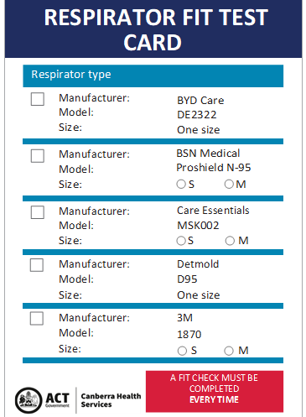

Attachment 8 Staff Fit Test Information and Results
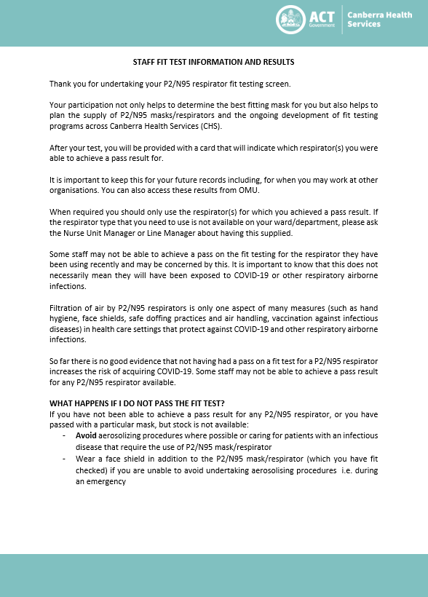

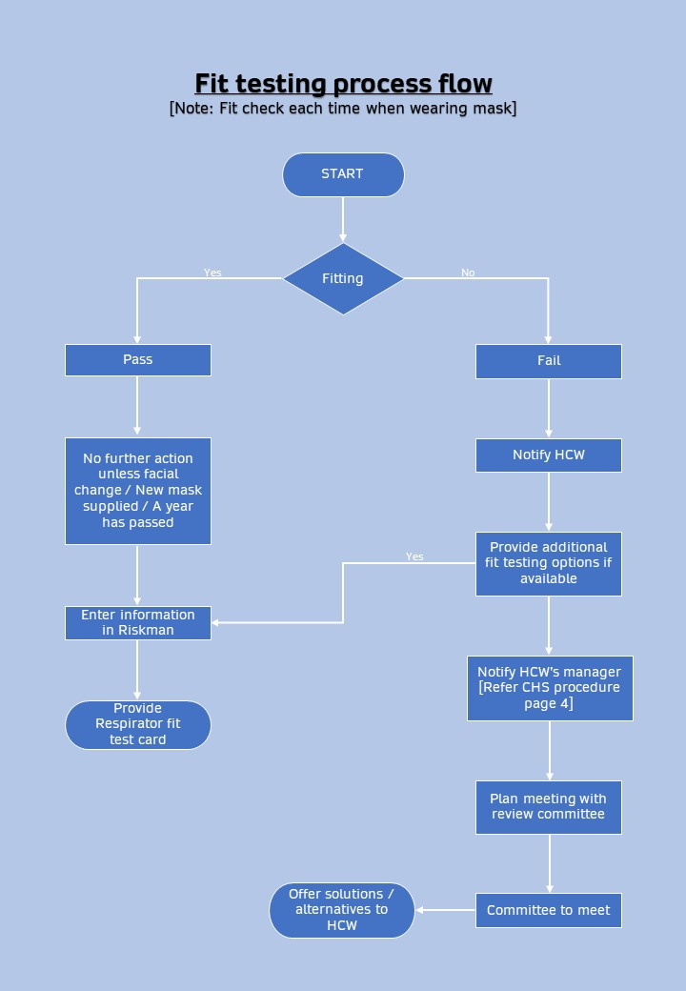
Attachment 9 – Fit Testing Process Flow

