**Canberra Health Services**

**Operational Procedure**

**Adult Acute Mental Health Services (AAMHS)**

|  |
| --- |
| Contents |

Contents 1

Purpose 3

Scope 3

Section 1 – Adult Acute Mental Health Services (AAMHS) 3

Section 2 – Bed Management 4

Section 3 – Admission Criteria 5

Section 4 – Direct Admissions 9

Section 5 – Inpatient Care 10

Section 6 – Advance Agreements, Advance Consent Directions and Nominated Persons 11

Section 7 – Clinical Handover 13

Section 8 – Patient Identification 13

Section 9 – Patient and Property Search 13

Section 10 – Management of Electronic Devices 17

Section 11 – Valuables and Property Management 17

Section 12 – Escort and Transport of People 19

Section 13 – Consumer Access to Leave 19

Section 14 – Visitors at AAMHS 20

Section 15 – Clinical Risk Assessment (CRA) 21

Section 16 – Restraint and Forcible Giving of Medications 28

Section 17 – Seclusion 28

Section 18 – Non-Adherence of Medication 28

Section 19 – Management of People subject to s.309 28

Section 20 – Medical Deterioration 29

Section 21 - Code Blue 29

Section 22 – Code Black 30

Section 23 – Use of Duress Alarms 30

Section 24 – Discharge 31

Section 25 – Environmental Safety Checks 32

Evaluation 32

Related Policies, Procedures, Guidelines and Legislation 32

Definition of Terms 34

Search Terms 36

Attachments 36

|  |
| --- |
| Purpose |

This document provides local operational procedures specific to the Adult Acute Mental Health Services (AAMHS) inpatient units at Canberra Health Services (CHS). Adherence to these procedures will ensure:

* Clinical practice supports the intended model of care
* Compliance with statutory responsibilities
* Adoption of evidence-based practice principles
* Practice which supports overarching CHS and Mental Health, Justice Health and Alcohol and Drug Services (MHJHADS) policy, procedures, and frameworks.

*Back to Table of Contents*

|  |
| --- |
| Scope |

This guideline applies to all people being treated within AAMHS inpatient units: Adult Mental Health Unit (AMHU), Mental Health Short Stay Unit (MHSSU) and Ward 12B.

This document applies to the following staff working within their scope of practice:

* Medical Officers
* Nurses and Midwives
* Allied Health Professionals
* Administrative Officers
* Students under direct supervision

*Back to Table of Contents*

|  |
| --- |
| Section 1 – Adult Acute Mental Health Services (AAMHS) |

The AAMHS inpatient units located at Canberra Hospital are operational 24 hours a day, 365 days a year, providing assessment, treatment and therapeutic intervention for people experiencing moderate to serious mental illness or mental dysfunction where less restrictive options have been deemed unsuitable or unavailable. The units include the AMHU High Dependency Unit (HDU) and Low Dependency Unit (LDU), MHSSU and ward 12B. All admissions to AAMHS inpatient units are in line with the *AAMHS Model of Care (MoC).*

All AAMHS inpatient units, along with all of Canberra Hospitalare approved mental health facilities under the *Mental Health Act 2015*, giving the units capacity to accommodate both voluntary and involuntary persons.

The AMHU is a dedicated 40 bed adult acute mental health inpatient unit located within Building 25 of Canberra Hospital. This unit has an 18-bed purpose built HDU inclusive of a 2-bed dedicated Vulnerable Persons’ Suite (VPS) and a 22 bed LDU.

The HDU model provides an environment of multi-disciplinary interventions for people with higher acuity mental health presentations. The HDU provides a specialised inpatient environment in which the treatment and safe management of acute mental health issues, agitation, behavioural disturbance, and clinical risk can be assessed and managed effectively. This is to include person-centred care at the forefront in the safest, least restrictive, and most respectful manner possible.

The LDU model provides an environment of multi-disciplinary interventions for people with lower acuity mental health presentations.

The MHSSU is a 6-bed acute mental health inpatient unit located within Building 2 of Canberra Hospital. The MHSSU model provides an environment of multi-disciplinary interventions for people with lower acuity mental health presentations.

Ward 12B is a 10-bed acute mental health inpatient unit located in Building 3 at Canberra Hospital. Ward 12B provides an environment of multi-disciplinary interventions for people with lower acuity mental health presentations.

All AAMHS inpatient units are staffed in line with the current nursing ratio outlined in the *Nursing and Midwifery Enterprise Agreement 2020-2022.*

* HDU 1:2 Morning, evening, and night shift
* LDU 1:4 Morning and evening; and 1:6 on night shift

Additional staff above ratios may be allocated to ensure staff and consumer safety and to enable care to be provided in line with the Model of Care (MoC).

*Back to Table of Contents*

|  |
| --- |
| Section 2 – Bed Management |

A multi-disciplinary team (MDT) of clinical staff work collaboratively with the person, their family, and carers, and or nominated persons on active recovery and discharge planning. Daily liaison will occur between the AMHU, MHSSU and 12B Clinical Nurse Consultant (CNC) and the Territory Wide Bed Access Coordinator to ensure open communication and oversight, and efficient prioritisation of patient flow across all inpatient units in conjunction with the Central Bed Management team.

All staff must be familiar with the *CHS* *Capacity Escalation Procedure*.

The Territory Wide Bed Access Coordinator is responsible for the escalation of bed access management issues and liaison with the Central Bed Management team. The CNCs are responsible for maintenance of the electronic patient journey board.

Medical staff must feedback plans for discharge to the Territory Wide Bed Access Coordinator as soon as practicable so the Nursing and Allied health teams can immediately progress discharge requirements and the Territory Wide Bed Access Coordinator can coordinate appropriate allocation to beds across the Territory.

*Back to Table of Contents*

|  |
| --- |
| Section 3 – Admission Criteria |

Admission to AAMHS can be initiated by the Mental Health Consultation Liaison (MHCL) clinician and/or the Psychiatry Registrar in consultation with the Psychiatry Consultant, or by an Emergency Department (ED) Consultant who may contact the on-call psychiatry consultant as required.

The AAMHS provides admitted inpatient units and standard hospital admission procedures and bed management processes apply.

An admission note is to be documented in the person’s electronic clinical record (ECR) by the MHCL Clinician and/or the Psychiatry Registrar/Consultant. The admission note should include a comprehensive mental health assessment, an admission plan, identified risks, Clinical Risk Assessment (CRA), At Risk Category (ARC) Score, Brøset Violence Checklist (BVC) and the legal status for the person.

*Mental Health Act 2015* and or *Crimes Act 1990* documentation is to be completed i.e. Voluntary/ Emergency Detention 3 (ED3)/ Emergency Detention 11 (ED11)/ Section 309 (S309). The ED3 and ED11 paperwork must be emailed to the Public Advocate and ACT Civil and Administrative Tribunal (ACAT).

If the MHCL clinician in conjunction with the Psychiatry Registrar are satisfied the person is not presenting with an acute medical condition, and a medical review is not completed; this must be documented in the clinical file and completed within 24 hours of admission.

Any available clinical test results i.e. urine drug screen, or pathology are to be reviewed with clear documentation of review.

An admission cover sheet, identification labels, medication chart and CRA are to be received from the ED.

The person is given an information sheet outlining their rights under the *Mental Health Act 2015*, specifically:

* the right to obtain a second opinion and the right to obtain legal advice;
* the right, if the person has decision-making capacity, to appoint a nominated person, enter into an advance agreement or make an advance consent direction;
* information about the role of a nominated person; and
* information about the location of information which is required to be available within AAMHS (e.g. copies of the *Mental Health Act 2015* and relevant legislation, information sheets relating to the *Mental Health Act 2015*, and information sheets in other languages).
* The person is verbally advised of their rights, this is to be documented in the person’s ECR.
* With the consent of the person, the nominated family, friends and/or carer are notified of the admission to AAMHS, and this is to be documented in the ECR.
* Access to leave and electronic devices is not permitted until the treating team has reviewed the person and completed a risk assessment.

*3.1 Admission Process*

* Prior to the arrival of the person to the mental health unit, the Nurse in Charge (NIC) will assign the person to an admitting nurse who will be responsible for ensuring the admission process is completed including checking that all admission paperwork has been completed by the admitting Registrar and these forms have accompanied the person on their transfer to the unit. Paperwork includes the CRA, medication chart, assessment note, BVC, patient identification labels, admission cover sheet and legal documentation.
* A handover using Identify, Situation, Background, Assessment and Recommendation (ISBAR) principles must be provided to the admitting nurse by the accompanying ED nurse if handover has not been provided verbally by telephone.
* During the handover process, the CRA will inform the nursing staff to commence an ARC form for the person from the time of arrival to the unit.
* In business hours, the admitting nurse must notify the treating team of the person’s arrival to the unit.
* With consent, the admitting nurse is to attend to baseline admission observations including temperature, blood pressure, respiratory rate, pulse, and sedation level.
* The admitting nurse is to ensure that the person has an identification band (white) or an *allergies bracelet (red). If the person refuses to wear an identification bracelet, this is to be documented in the ECR and a Riskman completed.
* The person’s belongings will be searched with their consent and items will be documented clearly on the persons Clothing, Property and Valuables Form preferably in the presence of the person.
* Any items of value are to be documented in the safe register and placed immediately in the safe located in medication room. Cash over $100 and/or any other items deemed to be of significant value, are to be placed in the hospital safe and a receipt provided to the person and documented in the person‘s ECR, this includes electronic devices.
* The person must receive an orientation to the unit, including room location, unit routines, visiting hours and meal times.
* The person must be offered access to basic toiletries and donated clothing (if required/available).
* With the person’s consent, their family, carer and/or nominated person should be contacted to inform them that the person has been admitted, where possible consulted, advised of the visiting hours and suitable belongings/items which can be provided to the person during their admission.
* The orientation pack will be provided to the person on admission and documented in the ECR.

The admitting nursing staff is to ensure that the admission process is completed including:

* Admission Checklist.
* The person is placed on the bed board and bed list by the NIC.
* The medication chart is reviewed and scanned to pharmacy if any medication is identified as not being available on the ward imprest. The admitting nurse must ensure the medication chart is included in the patient folder.
* A Health of a Nation Outcome Scale (HoNOS), and Behaviours of Concern (BOC) should be completed by the assessing MHCL clinician in ED. However, if this has not been completed it is the responsibility of the admitting nurse to complete.
* Document an ISBAR admission note in the persons ECR.
* The NIC is to ensure that DIETpas has been updated on admission with specific diet requirements.
* If the admitted person has been admitted under the *Mental Health Act 2015*, a written and verbal explanation of their rights must be given and documented in the clinical notes. This should include a description of the role of both legal aid and the public advocate and facilitating contact if requested.
* The person is to be informed of the requirement to keep their electronic devices in the safe until the treating team has completed a review.
* The person is to be informed of the requirements to access leave from the unit.

*3.2 Admission of an Adolescent*

* Consultation between Child and Adolescent Mental Health Services (CAMHS) and the admitting consultant psychiatrist is required prior to any admission of an adolescent to AAMHS.
* When an adolescent is admitted to AAMHS, considerations must be given to their psychological and physical safety and vulnerability from the other persons and/or visitors to the ward.
* Consideration should be made in allocating the adolescent to a VPS wherever possible, or a room which is within proximity to the nurses station.
* For existing CAMHS clients admitted to AAMHS, regular reviews by CAMHS will occur in consultation with the adolescent, their family and/or carer, and the treating team.
* Consideration for 1:1 care should be given on a case-by-case basis.
* The use of the Paediatric Early Warning Score (PEWS) should be used for all young persons admitted to AAMHS.

*3.3 Allied Health*

A Psychosocial Needs Assessment is a recovery focussed plan completed by the AAMHS allied heath team once someone is admitted and complex, or multiple needs have been identified. It is preferable that the allied health staff allocate admitted persons within their assigned teams to support continuity of care within the MDT. This assessment will then assist in the recovery and discharge planning that occurs in collaboration with the person, their family and carers, or nominated person and stakeholders.

As soon as is practicable, following a person’s admission to AAMHS:

* When need is identified, a Psychosocial Needs Assessment is completed by allied health team member and person informed about the different allied health services available on the ward.
* The person’s family, carer, guardian and/or nominated person will be contacted and a family meeting will be organised by the social work team or treating doctors if Social Work will not otherwise be involved with the episode of care of the person. Carers are to be involved in discharge planning from the as soon as appropriate after admission.
* A person’s requirements for Occupational Therapy services will be identified.
* A person’s requirements for social work and welfare services will be identified including Domestic Violence, housing issues, and family/carer assessment and supports.
* A person’s requirements for Psychology services will be identified.
* A person’s requirements for Exercise Physiology will be identified.
* A person’s requirements for Art Therapy will be identified
* A person’s needs are to be addressed through encouragement of participation in the Therapeutic Group Program (TGP). This will be identified and initiated as soon as practical after admission.
* National Disability Insurance Scheme (NDIS) status clarified, and the person’s support coordinator notified of admission and if possible, changes to their plan are identified.
* Discharge planning will have commenced.

*3.4 Psychiatry*

* A comprehensive psychiatric assessment of persons admitted to AAMHS will identify any critical elements of care and treatment. The assessment must include the following information:
  + Presenting complaint, including history of presenting complaint;
  + Social history;
  + Alcohol and drug history;
  + Family history;
  + Medical history including current medical issues, medication allergies;
  + Risk assessment (including risk of harm to self and others) and completion/review of the CRA to provide a recommended inpatient observation level; assessment of suicidality, general vulnerability, aggression/violence assessment to inform BVC, and right to access leave;
  + Mental State Examination (MSE);
  + Impression (provisional diagnoses, differential diagnosis);
  + Plan, including permission to speak with the family, nominated person and/or carer and include in decision making.

*3.5 Medical*

Section 86 (2) of The *Mental Health Act 2015* directs the need for a thorough physical examination by a doctor for all persons who are detained on an ED3 within 24 hours.

It is the responsibility of the treating team to ensure that all persons admitted to AAMHS have been or are offered a comprehensive medical examination within 24 hours of admission, recorded and signed in the person’s ECR. This is a divisional Key Performance Indicator (KPI) and is reported on monthly.

If a physical examination is not possible within this time frame (e.g. if it would be

distressing to the person to undergo a physical examination due to his or her mental state or the person refuses), then the reason should be clearly stated in the notes, any relevant observations documented (e.g. gait, posture, energy levels, levels of hydration, nutritional status), and continued attempts should be made to undertake the examination.

Physical assessment should include completion of the following:

* Liaison with any other specialties involved in the persons care.
* Medical history.
* Details of past and present physical illnesses. Where there are enduring medical conditions, e.g. epilepsy, asthma etc. the type and frequency should be recorded, and the emergency intervention strategies.
* Relevant family history, e.g. diabetes, coronary heart disease.
* Current medication.
* A comprehensive symptom review followed by a complete physical examination.
* An assessment of the impact of lifestyle factors on physical and mental health including:
  + Alcohol and drug usage
  + Diet
  + Sexual health
  + Exercise
  + Sleep
  + Details of health screening (e.g. cervical, breast) and relevant immunisation (e.g. flu vaccination).
  + Clinically indicated investigations.
  + If there are any concerns or indications of illicit drug use, a urine test should be done as soon as possible.
* Blood tests UEC, LFTs, TFTs and FBC as standard.
* Tests for hormones if symptomatic (e.g. raised prolactin, hypogonadism).
* If BMI over 30, referral for specialist assessment should be made.
* Consideration should be given to the need for a chest X-Ray.
* Where there are organic indicators, the need for scans should be discussed with the Consultant.
* Medical Clearance to use the exercise equipment is required.

Please refer to *Attachment 8*, MHJHADS Physical Exam and Investigations Form.

*3.6 Administrative Responsibilities*

AAMHS administrative staff should comply with the *CHS Admission to Discharge Procedure (Adults and Children).*

*Back to Table of Contents*

|  |
| --- |
| Section 4 – Direct Admissions |

A direct admission to AAMHS refers to the planned transfer of clinical care from the community or other health care facility to the inpatient setting. This type of admission must be arranged by the primary treating team, accepted by the AAMHS Clinical Director (or delegate) and the decision made in collaboration with the person requiring the admission, their Carer, Nominated Person and or family.

Direct admissions are only to occur in business hours in consultation with the Territory Wide Bed Access Coordinator. If a direct admission is unable to be facilitated and the person requires emergency treatment, they must present to ED for assessment. If it is a non-emergency and there is bed capacity, the Territory Wide Bed Access Coordinator will reassess the next business day.

The accepting MDT will complete the admission procedures as outlined in Section 3 of this document.

**Note**:

AAMHS ability to accept direct admissions is dependent on several factors including bed availability, ward acuity, delayed discharges and clinical demand from the ED and other wards of Canberra Hospital.

*Back to Table of Contents*

|  |
| --- |
| Section 5 – Inpatient Care |

The team will work collaboratively within professional and legal frameworks to ensure the safe delivery of mental health in-patient care for persons admitted to AAMHS based on best available evidence-based practices.

Admissions within AAMHS should be recovery focused, therapeutic, person centred and allow informed decision making underpinned by the *Mental Health Act 2015*. The *Mental Health Act 2015* requires the inclusion of carers and family members in the provision of mental health services. The provision of treatment, care and support must facilitate the appropriate involvement of family, carers, and close friends in collaborative treatment decision-making. Acknowledgement of the contribution that carers provide in the care planning and recovery of persons is in line with the *Carer Recognition Act 2021.*

While AAMHS staff recognise the experience and expertise of family, carers, and close friends, AAMHS staff adhere strictly to the *Health Records (Privacy and Access) Act 1997*, which informs the disclosure of an admitted person’s health information.

Persons admitted to AAMHS will also have access to a variety of opportunities to engage with the TGP such as social groups; recreational groups; skills-based groups; self-help groups; pet therapy groups; community information groups; physical exercise groups; psychoeducation relating to symptoms management, diagnosis and treatment choices and recovery; a Consumer Consultant; and clinical consultation provided by Alcohol and Drug Services (ADS).

*5.1 Operational Management of the HDU*

An environmental, procedural, and relational approach to safety is to be adopted in the HDU environment.

All staff must carry and be familiar with the operation of the fixed and personal duress alarms and are required to respond to activated alarms.

HDU staff will undertake an environmental audit each shift. Two nursing staff on the same shift in HDU must complete the audit. The NIC must be immediately notified if any concerns are identified.

All AAMHS staff should comply with and refer to the *CHS Occupational Violence Operational Procedure.*

All admissions or transfers into the HDU will require a CRA review and provided with an updated ARC. All persons admitted to HDU are assessed and score an ARC of 4 or higher.

If clinically indicated, the senior nurse on duty may initiate the transfer of a person into the HDU from another AAMHS inpatient unit and have the decision ratified as soon as practicable by the Consultant Psychiatrist or Psychiatry Registrar.

Before transferring persons out of the HDU, a further CRA must be completed by the nursing staff, Psychiatry Registrar or Consultant Psychiatrist to ensure the transfer is appropriate, with a reduced ARC of 3 or less. The HDU staff must provide a verbal handover based on ISBAR and the ARC observation form handed to the nominated LDU staff member who will be taking over the care for the person being transferred.

Persons admitted to the HDU are considered as high priority to be reviewed by their treating teams, including the Psychiatry Registrar at a minimum.

Treating teams must identify persons who have the potential to be transferred from the HDU into the LDU if a bed is required urgently. These persons are to be identified in the AMHU morning meeting and a management plan documented by their treating team.

Concerns relating to the clinical deterioration of a person in HDU are to be immediately escalated by HDU staff to the Shift Team Leader. This may be indicated by, but not limited to:

* a notable change in the person’s behaviour or physical condition,
* medication refusal,
* an increase in the persons potential for aggression and violence as identified through the BVC, and/or
* an increase in a person’s suicide vulnerability.

The Psychiatry Registrar is to be contacted and asked to review the person. Out of hours the on-call Psychiatry Registrar and/or Consultant Psychiatrist is to be informed and requested to review the person as soon as possible.

For information regarding visitors in the HDU, please refer to Section 14 of this document.

*Back to Table of Contents*

|  |
| --- |
| Section 6 – Advance Agreements, Advance Consent Directions and Nominated Persons |

The *Mental Health Act 2015* identifies several ways that a person can express preferences for treatment, care, or support when they have decision-making capacity in anticipation of future loss of decision-making capacity. These include entering into an Advance Agreement and/or an Advance Consent Direction, and/or nominating a Nominated Person.

All staff must adhere to the directions as set out within the *C**HS Advance Agreements, Advance Consent Directions and Nominated Persons under the Mental Health Act 2015 Operational Procedure* which provides guidance to staff to assist people in making Advance Agreements, Advance Consent Directions and explains the rights, roles and responsibilities of staff, the person, and the Nominated Person in relation to these legislated provisions under the *Mental Health Act 2015*.

AAMHS staff must review the ECR to determine as to whether a person has an existing Advance Agreement which will guide the treatment received during the acute care episode. A scanned (PDF) version of the Agreement will be attached in the ECR and titled “Advance Agreement”. It may also be referred to on the ALERT function of the persons ECR.

The wishes expressed in a person’s Advance Agreement forms the basis of the treating team’s approach in supporting the person’s recovery, particularly during times of illness and reduced ability to communicate these wishes. They are considered when making decisions about treatment, care, or support. The Advance Agreement will guide the treatment, care or support provided if it is effective and considered in their best interest at the time.

If a person’s wishes cannot be followed in accordance with their Advance Agreement (for example, if the preferred person is not available to care for the person’s property), an explanation and alternative agreement will be documented in the person’s clinical record.

AAMHS staff must review the ECR to determine as to whether a person has an existing Advance Consent Direction. A signed and scanned (pdf) version of the Direction will be attached in the ECR and titled “**Advance Consent Direction**”. It may also be referred to on the ALERT function of the persons ECR.

If an Advance Consent Direction is in place and the person currently does not have decision making capacity, the treating team may give the treatment or medication to which the person has consented in the Advance Consent Direction and **must not** give any treatment or medication for which consent is explicitly not given in the Advance Consent Direction.

If a person who has an Advance Consent Direction does not have decision-making capacity, the matter will be reviewed by the ACAT and the Tribunal Liaison Team will make a determination as to whether the required treatment, care or support can be provided as per the Advance Consent Direction.

A Nominated Person is identified in the *Mental Health Act 2015* as someone who can help a person with a mental illness or mental disorder by ensuring the person’s interests are respected if they require mental health treatment, care, or support. Nominated Persons also receive notifications and information as outlined in theAct and are consulted on decisions in related to the treatment, care or support provided to the person experiencing the mental illness or mental disorder. AAMHS staff must review the ECR to determine as to whether a person has an existing Nominated Person. This will generally be found through the **ALERT** function on the ECR.

A Nominated Person does *not* have the power to make treatment or other decisions on behalf of the person with a mental illness or mental disorder.

*Back to Table of Contents*

|  |
| --- |
| Section 7 – Clinical Handover |

All AAMHS staff should comply with and refer to the *CHS Clinical Handover Procedure.*

MDT discussions relating to clinical care must be contemporaneously documented into a person’s ECR by a designated MDT clinician.

Please refer to *Attachment 4* for AAMHS MDT Meeting Daily Agenda.

*Back to Table of Contents*

|  |
| --- |
| Section 8 – Patient Identification |

All AAMHS staff should comply with and refer to the overarching *CHS Patient identification and Procedure Matching Procedure.*

**Alert**:

Under no circumstances should staff place themselves at unnecessary risk by insisting persons comply with the wearing of an identification band.

*Back to Table of Contents*

|  |
| --- |
| Section 9 – Patient and Property Search |

In limited circumstances, searches may be conducted within AAMHS to detect and reduce the risk of items that would present a danger to anyone in the unit or could be used by the person to abscond. All visitors and persons are made aware of prohibited items, through the Welcome to AAMHS handbook that is provided. For guiding principles relating to consent and safeguards regarding a search of a person, please refer to the *CHS Searching of a Consumer’s Person or Property Policy.*

A search is only lawful if it is:

* Conducted by an authorised person (see section 9.2), and
* The authorised person has reasonable grounds to believe that the person is carrying anything that:
* would present a danger to the authorised person or another person; or
* could be used to assist the person to escape the authorised person’s custody.

**An unlawful search is a violation of the person’s human rights and may constitute a criminal offence.**

Searches of persons admitted to AAMHS should be conducted in a planned, systematic, and safe manner and only if there are reasonable grounds to do so.Searching must always be done in an efficient, conscientious, and least intrusive manner. It should never be viewed as a routine ‘chore’ to be carried out in a cursory fashion. To do so would seriously compromise the safety and security of AAMHS or therapeutic relationships with persons. Searches must never be conducted as punishment or to intimidate or elicit compliance for other actions.

A search is an intrusive measure, which may be traumatic to a person. Authorised persons (see section 9.2) conducting a search should always act in a professional manner that demonstrates concern and respect for the person and their property.

The Authorised person conducting the search should be of the same sex of the person or, if this is not practicable, another person of the same sex or a sex nominated by the person must be present while the search is conducted.

The search must be conducted in a way that provides reasonable privacy for the person, usually the person’s bedroom, and completed as quickly as possible.

*9.1 Search and a person’s legal status*

An authorised person (see section 9.2) may conduct an ordinary search or pat down search of a person, a person’s property (see definition of terms) or the bedroom of a person who is subject to emergency detention (ED3 or ED11) or a mental health order, i.e. an Assessment Order (AO), Psychiatric Treatment Order (PTO), CCO, Forensic Psychiatric Treatment Order (FPTO) or Forensic Community Care Order (FCCO).

Scanning searches can only be conducted on the above persons by a security officer at the direction of an authorised clinician, as only security officers are trained and licensed to operate the scanning equipment.

There are no powers within the *Mental Health Act 2015* for voluntary persons to be searched without their consent. However, in order to keep everyone safe at AAMHS and to prevent other persons on an involuntary mental health order from acquiring items that could be used to facilitate an escape, all persons admitted to AAMHS may be asked to participate in a search to the extent allowed under common law.

*9.2 Authorised people*

Only the following people may conduct searches of persons admitted to AAMHS:

* Consultant Psychiatrist;
* Registrar;
* Medical Officer;
* ADON, AAMHS;
* Registered Nurse, only at the direction of the ADON or above; and
* A security officer, only at the direction of the ADON or above.

Authorised people have a responsibility to ensure that searches are carried out in a manner consistent with the principles of care and treatment set out in the *Mental Health Act 2015*. That is, any interference with the person’s rights, dignity and privacy is to be kept to the minimum necessary in the circumstances. The therapeutic safety and security of all persons in the Unit remains paramount.

*9.3 Types of Searches*

*9.3.1    Scanning Search*

A scanning search is a search of a person and their personal items by electronic or other means that does not require the person to remove their clothing or to be touched by someone else.

For further information on undertaking a scanning search, see *Attachment 6.*

If the item still cannot be located, and a reasonable belief remains that the person is in possession of an items that may present a danger to anyone in AAMHS or may be used by a person to escape from AAMHS, an ordinary or pat down search (also known as frisk search) of the person may be required.

*9.3.2 Ordinary Search*

An Ordinary Search is a search of a person, or of articles in the person’s possession that may include:

* Requiring the person to remove an overcoat, coat or jacket and any gloves, shoes, or headwear.
* An examination of those items.

For further information on undertaking an ordinary search, see *Attachment 6.*

If the item still cannot be located, and a reasonable belief remains that the person is in possession of items that may present a danger to anyone in AAMHS or may be used by a person to escape AAMHS, a pat down search of the person may be required.

*9.3.3 Pat Down Search*

A pat down search is a search conducted by quickly running the hands over the persons’ outer garments and examining anything worn or carried by the person that is conveniently and voluntarily removed by the person.

For further information on undertaking an ordinary search, see *Attachment 6.*

*9.3.4 Personal property and bedroom searches*

An authorised person may conduct a search of a person’s bedroom or property if there are reasonable concerns that the person is in possession items that may present a danger to anyone in AAMHS or may be used by a person to escape from AAMHS.

Before commencing a personal property or bedroom search, the Authorised person conducting the search must explain to the person why a search is necessary.  Every effort should then be made to obtain the person’s verbal consent and cooperation. Consent may be withdrawn at any stage, although a person admitted involuntarily should be informed that a search may proceed even without consent.

The person, or a person nominated by the person, must be offered the opportunity to observe the bedroom search.

During this search, the person should be supervised to ensure items are not concealed or removed from their room. Prior to a bedroom search, an Authorised person may conduct an ordinary search (see definition of terms) of the person.

When any bedroom search is conducted without consent a Clinical incident report must be completed by the authorised person leading the search.

*9.4 What to search for*

When conducting a search, the authorised person should search for any item or items that present a danger to anyone in AAMHS or may be used by a person to escape, including:

* items that may cause injury to others or used to self-harm;
* ignition sources (matches, lighters, battery chargers);
* alcohol, including items that may be used to brew alcohol e.g. yeast and sugar products;
* drugs or other substances that may adversely affect a person’s mental state and interfere with the treatment process;
* items that may present a health or hygiene hazard e.g. open foodstuffs;
* material or items that, when held in quantities may indicate undesirable activity e.g. hoarding of medications; and

*9.5 Documentation*

A post-incident review by the MDT must follow every search undertaken where consent has been withheld. The review should include consideration for the provision of any additional support for the staff and person involved. The review must include offering the person contact with the Public Advocate and the Official Visitor. Details of the review must be documented in the person’s ECR.

All searches on a person must be recorded in the ECR and in the Search Register.

Any issues that occurred during the search, e.g. refusal of search, injury during search, use of force, location of a seizable item, must also be documented and all adverse events must be entered onto Riskman.

*9.6 Seizure of items*

A person who is authorised to conduct a search may seize an item found in the search which would present a danger to the person, staff, or other persons, or which may be used to assist the person to escape from AAMHS. Two members of staff must witness, document and co-sign storage of the removed item in the consumer’s property form and a description of the removed item must be documented in the person’s ECR. The item must be returned to the owner of the item on discharge, or reasonable compensation paid to the owner by the Territory for the loss of the item, unless:

* a prosecution for an offence against a territory law in connection with the thing is begun within one year after the item was seized and the item is required to be produced in evidence in the prosecution; or
* an application for the forfeiture of the thing is made to a court under the *Confiscation of Criminal Assets Act 2003* or another law within one year after the day the seizure is made; or
* all proceedings in relation to the offence with which the seizure was connected have ended and the court has not made an order about the thing.

**Note**:

The item does not have to be returned to the person if the authorised person believes on reasonable grounds that:

* the only practical use of the thing in relation to the premises where it was seized would be an offence against this Act; or
* possession of the thing would be an offence; or
* possession of the thing would present a serious risk or threat to a person.

For the removal of suspected prohibited substances from the person, please refer to the *CHS* *Responding to Consumer Use of Alcohol and/other Drugs (AOD) Procedure*.

*Back to Table of Contents*

|  |
| --- |
| Section 10 – Management of Electronic Devices |

All AAMHS staff should comply with and refer to the *CHS Patient Mobile and Recording Devices: Management and Use Operational Procedure*. Unrestricted access to personal electronic devices, including mobile phones, cameras, and video recording devices, is not permitted in AAMHS.

On admission, persons will be:

* Informed as part of their orientation to the unit that the use of electronic devices is restricted while admitted to the unit.
* Encouraged to give their electronic devices to a carer or significant other for safekeeping at home.
* Encouraged to hand over their electronic devices to staff for safekeeping so that it may be entered in the property sheet and stored securely.
* Encouraged to take a copy of any important phone numbers and contacts before it is stored.

Persons admitted to HDU are not permitted to have access to their electronic device unless directly supervised by staff and for the purpose of retrieving messages and or contact details. Persons admitted to the HDU will be supported to make phone calls via the unit phone.

Persons using electronic devices in LDU will be encouraged to keep them in their rooms which are lockable.

Any person admitted to AAMHS who has been found to breach the acceptable handling of these devices will have them removed for safekeeping. The treating team will be informed, and the person will only be permitted to have access to their electronic device when directly supervised by staff until the risk can be mitigated and or is reduced.

*Back to Table of Contents*

|  |
| --- |
| Section 11 – Valuables and Property Management |

On admission, each item of a person’s property, including valuables, electronic devices, personal documents, and money must be recorded and described on the Patient Valuables Receipt and Transaction Record, this includes belongings worn on admission Staff completing the form should describe brand names and general condition of all items, e.g. Blue Shorts, red ‘Billabong’ shirt, good condition. A copy of the Patient Valuables Receipt and Transaction Record will be provided to the person for them to retain and an updated form can be provided upon request. The form is to be scanned into the person’s ECR.

Valuable items are to be put into safe keeping and where possible, the person should be encouraged to return valuables to a family member or carer.

The admitting nurse is to ensure that the person signs the discharge checklist that states that the person accepts responsibility for their items whilst an inpatient and has received all property and valuables on discharge. This form is then placed in the person’s ECR.

All electrical items brought into AAMHS must appear to be in good working order on visual examination. The length of any cable/lead designed to be attached to or connected to any electrical item, must be the subject of a risk assessment by the MDT.

The After-Hours hospital CNC and Security can be paged to request assistance with accessing and transferring items to the hospital safe**.**

All items placed in the safe are to be put in a zip up safe bag with the persons identification label on the outside of the bag. All items in the safe are to be logged in the valuables book and signed by two nurses.

Staff members are to ensure that a person’s valuables receipt and transaction form is completed and where possible this is signed by the person.

The key for the safe is to be always kept with the shift team leader who retains responsibility for its use.

The AMHU safe may be used to store money (under $100) for those persons who require assistance with budget management and where an individual plan is in place. The maximum amount of money stored in the safe will be $400. All the above procedures are to be followed.

A patient valuables receipt and transaction record form is to be completed as above.

Watches, rings, and other items of jewellery should be objectively described with no reference to ‘gold’ or ‘silver’ or any other precious metal. Instead describe all items as ‘yellow metal’ or ‘white metal’ or ‘clear stone’. Where possible the person is to sign the receipt.

The valuables are to be placed in a valuable’s envelope with the person’s name and ward/unit documented on the outside of the envelope.

The security office is to be contacted to deposit valuables in the hospital safe between Monday to Friday 0800-1600hrs.

If a person reports a missing item, staff need to investigate this fully, clarifying when the item was last seen and from where the item went missing.

Though discouraged, persons do trade and give away items. Property may deteriorate over time and may be discarded. All these avenues are important to explore when a person reports a missing item. Lost or stolen items may be recovered by way of a unit search or, where necessary, a search of an individual room or person. The dignity of all concerned must be maintained if searches are conducted (see *Search section*).

If valuables that the unit has taken responsibility for storing and safe keeping are reported as missing this needs to be investigated by the ADON and reported to the Director of Nursing (DON) for appropriate management.

**Note:** Ensure the person is aware that the hospital cannot accept full responsibility for loss or damage to personal effects unless property was taken into safe keeping.

*Back to Table of Contents*

|  |
| --- |
| Section 12 – Escort and Transport of People |

All AAMHS staff should comply with and refer to the *CHS Non-urgent Escort and Transport of People with a Mental Illness (MHJHADS) Procedure.*

If a person absconds, staff members need to initiate the *CHS Missing Patient Procedure* and immediately advise the DON or Executive on call after hours.

*Back to Table of Contents*

|  |
| --- |
| Section 13 – Consumer Access to Leave |

Granting authorised leave facilitates several important functions:

* To offer a person with or without a carer, or support person the opportunity to return to their usual environment for a trial period.
* To monitor the person’s progress and recovery towards the estimated discharge date (EDD).
* To be part of an ongoing assessment process.
* To allow the person to carry out important activities or business.
* To ascertain suitability for longer leave.
* To prepare for discharge.

The utilisation of the CRA framework must precede any decision to allow a person (who is voluntary or involuntary under the *Mental Health Act 2015)* periods of authorised leave. This should be discussed in collaboration with the MDT.

The determination of risk level should be consistent with the level of care the person is receiving at the time of granting leave.

Family, carer or nominated persons should be engaged where appropriate in providing support when a person is granted authorised leave. Following a risk assessment, safeguards are required to ensure the person’s wellbeing while on leave. It is important to ensure that the family, carer or nominated person are informed of issues that may affect the person and are able to agree and accept responsibility for the person while on leave. These details are to be recorded in the person’s ECR.

If the person has been granted unescorted leave, they are to have a risk assessment prior to leaving the unit. They are also to be aware of the limits of the leave are (such as time allowed, location etc).

It is the responsibility of the allocated nurse to document in the person’s ECR: when a person proceeds on leave, when they return and the outcome of that period of leave including contact details. This documentation should occur for every episode of leave and should include a current description of their clothes, where they are on leave to and legal status

There are several leave provisions in the *Mental Health Act 2015* that are applicable to involuntary person detained in a mental health facility. Providing a person with leave is recognised as an important and integral part of the care and rehabilitation process.

*Back to Table of Contents*

|  |
| --- |
| Section 14 – Visitors at AAMHS |

Visitors and carers are always welcome at AAMHS. The AAMHS team recognise the important role that families and carers have in supporting persons and for the need to have them actively involved in treatment and discharge planning.

Visiting AAMHS will be facilitated with the permission of the person concerned, contact prior to visiting is recommended. Visitors to AAMHS will be provided with a copy of the Information for Visitors brochure and the nursing staff will communicate key information to them such as:

* All possessions and items to be given to persons admitted to AAMHS must be checked by staff first
* Visitors are to be reminded that persons are **not to be given** medications additional to their prescribed regime on the unit
* Under no circumstances are alcohol, drugs, knives/weapons, cigarette lighters/matches, sharp objects, or other prohibited items to be brought onto the premises, offered to, or given to persons
* Children **must not** visit unaccompanied and are to be under adult supervision at all times.
* Personal belongings should be kept in the designated lockers at the reception area

Visitors should be provided a quiet and private area in which to enjoy their visits. Where possible, visitors with children should have access to areas in which children may play under parental supervision. Visitors are not to visit persons in their rooms.

Wherever possible visitors are not to be exposed to sensitive situations (e.g. overt aggression, abuse, giving of injections or medications).

Visitors determined by staff to not have a legitimate cause to be on the unit visiting persons are to be asked to leave. If they do not comply with this request, they are to be informed that they are trespassing, and the hospital Security should be contacted.

Visitors should be made aware of the resource area at reception that provides:

* a beverage bay, vending machine.
* access to toilet / bathroom/ baby change facilities.

Details of all visits with persons are to be recorded in the person’s ECR regardless of whether new information has been forthcoming, or some incident has occurred.

In the event of violence or aggression by a visitor, staff are to be familiar with the *CHS Occupational Violence Operational Procedure.*

The safety of admitted persons, staff and visitors is paramount. Nursing staff should conclude a visit if they feel that the safety of the person, visitors or staff may be compromised. In the event where a visitor becomes distressed by their visit, supportive counselling is to be offered by staff.

Visitors by a lawyer, Official Visitor or the Public Advocate are allowed for persons admitted under a section 309 of the *Crimes Act 1900*. Any other visitors or the making of phone calls must be agreed with the Australian Federal Police (AFP) in accordance with CHS Operational Procedure *Management of People Subject to Section 309 of the Crimes Act 1900 Transferred to the Canberra Hospital (Mental Health, Justice Health & Alcohol and Drug Services).*

Support Workers can attend from various non-Governmental organisations (NGO) to support discharge planning and transition to the community. Support workers should identify themselves at reception and state who they wish to visit. The NIC must assist the Support Worker and provide a temporary key pass if required/available. If the Support Worker wishes to take the person off the unit for leave, the planned destination activity and time of return must be approved by the NIC. The NIC must ensure that all details of the Support Worker are listed on the patient leave form which is to be stored in the patient file.

All visitors should be aware that entry to CHS facilities is in line with current Clinical Health Emergency Coordination Centre (CHECC) advice as part of the Territory-wide clinical response to COVID-19.

*Back to Table of Contents*

|  |
| --- |
| Section 15 – Clinical Risk Assessment (CRA) |

Persons admitted to AAMHS will have an initial CRA (Attachment 1) completed using the initial CRA form. The initial CRA will be completed in the ED by the Psychiatry Registrar prior to admission, for direct admissions this is completed on initial presentation by the medical ward. The CRA must be ratified by the AAMHS treating team as soon as practicable after admission.

An ARC will be established at the completion of the initial CRA which will determine the level of observation required for each person admitted to AAMHS.

Risk factors that may indicate the need for closer observation include:

* Suicidality or a history of previous suicide attempts or acts of self-harm
* Aggression / violent behaviours / harm to others, risk-rated utilising the Brøset
* Delusions, particularly paranoid ideas where the person believes other people may pose a threat
* Hallucinations, particularly voices suggesting harm to self or others
* History of absconding
* Poor adherence to medication programs
* Alcohol and Drug misuse
* History of inappropriate sexual behaviour
* Cognitive impairment
* Medical condition
* General vulnerability

The CNC/NIC is responsible for allocating appropriately trained or qualified staff to carry out the level of observations required.

*15.1 Levels of Engagement including observation*

The AAMHS believes that risk assessments are an integral part of the care provided in an acute inpatient unit and are best done collaboratively with the person, family/carer/nominated person, and the treating team. Risk assessments are recorded on the CRA form to inform a decision about the level of risk management that the person requires.

There are 5 levels of ARC observation:

|  |  |  |
| --- | --- | --- |
| Arc Level | Level of Risk | Description |
| Level 1 | Low risk | General Engagement and Observations every 2 hours |
| Level 2 | Low to Medium risk | Intermittent Engagement and Observation every 50-60 minutes |
| Level 3 | Medium risk | Frequent Engagement and Observation every 20- 30 minutes |
| Level 4 | Medium to High risk | Close Engagement and Observation every 10- 15 minutes |
| Level 5 | High risk | Continuous Engagement and Observation |

The initial risk assessment is comprehensive and includes static and dynamic risk factors/history of risk AND is informed by relevant collateral and corroborative information. Collateral & corroborative information should be sought from the person’s supports; General Practitioner and relevant others who may have useful information. Where this type of information is not available, the level of assessment confidence needs to be considered. Low assessment confidence flags the need for a more conservative approach to managing risks when developing a risk management plan with the person.

Engagement and interaction with persons are a clinically valid, therapeutic tool utilised to manage, contain, and more accurately monitor issues of risk. In a mental health setting, the CRA reinforces this important concept using therapeutic engagement and observation throughout admission to hospital, based on assessed level of risk and principle risk concern(s).

Adolescents (aged 12 up until 18th birthday) who are admitted to AAMHS are required to be placed on an ARC 5 prior to admission, unless following an initial mental health and risk assessment by the ED CAMHS Consultation Liaison team it is felt that an alternative ARC score can be used to better meet the needs of the young person, based upon clinical need, therapeutic benefit and reduction of trauma if indicated. An ARC score lower than ARC 5 must also take into consideration the admitted patient cohort in the unit and the adolescents’ safety.

*15.1.1 ARC 1 (General Observation) – 2 hourly*

General observation is the minimum acceptable level of observation for a person admitted to AAMHS. Prior to any person being placed on Level One / general observation a full risk assessment must be completed by the admitting staff member to assure that the individual does not pose any serious risk to either themselves or others. This initial risk assessment should also consider the potential vulnerability of the person within the unit.

Every person admitted to AAMHS will have a designated staff member who will have knowledge of their whereabouts, whether on or off the unit, but not all persons need to be kept within sight. Staff will check on the person’s whereabouts at handover times of nursing staff and at all meal times.

Persons on level one observation should also be deemed to be unlikely to attempt to leave the unit on unauthorised leave. Consideration can be given to if the person can have their phone/tablet/headphones/charger while they are an inpatient. This is to be documented in their notes.

The person must be informed and actively involved in the process. The responsible nurse will engage with the person to assess mental state and record objective and subjective (i.e. the person’s views) information in the ECR.

*15.1.2 ARC 2 (Intermittent engagement and observations) – 50-60 Minutes*

This level of observations is considered suitable for those persons, who following a risk assessment, are considered to be requiring a degree of supervision higher than which is provided to persons receiving ARC 1 observations.

Such persons may be deemed to be potentially, but not immediately, at risk to either themselves or others. Alternately, there may be persons who are considered to be vulnerable within the unit setting or may be identified as likely to leave the unit without informing staff. Intermittent observations should occur every hour.

More frequent checking is strongly advised in the case of persons whose risks are deemed to be higher, and it is recognised as good practice to periodically alternate the times of checking to avoid persons becoming too familiar to the routine of staff checking on them e.g. check after 50 minutes, check after 55 minutes, check again after 60 minutes and so on. Consideration can be given to if the person can have their phone/tablet/headphones/charger. This must be documented in their notes.

*15.1.3 ARC 3 (Frequent observations) – 20-30 Minutes*

This level of observations is considered suitable for those persons, who following a risk assessment, are considered to be requiring a degree of supervision higher than which is provided to persons receiving ARC 2 observations.

This level of observation should be used for persons considered to pose a significant risk of:

* Suicide /Self harm
* Overt psychotic symptoms
* Harm to others
* Falls
* Absconding
* Severe self-neglect
* Violence, aggression, or physical harm

Whilst under ARC 3 observations the whereabouts of the person must, at all times, be known by the nominated nurse and the person sighted every 20-30 minutes. It is important to review daily so there is no undue delay in re-grading the ARC to the lowest level of appropriate observation and least restrictive practices.

Consideration can **ONLY** be given to if the person can have their phone/tablet/headphones/charger after a discussion with the MDT and documented in the ECR and noted on the bed list.

*15.1.4 ARC 4 (Close observations) – 10-15 Minutes*

This level of observation should be used for persons within the HDU considered to pose a significant risk of:

* Suicide /Self harm,
* Overt psychotic symptoms,
* Harm to others,
* Falls,
* Absconding,
* Severe self-neglect,
* Violence, aggression, or physical harm but not to the degree of needing to receive level four observations (within arm’s length).

The person must be informed of ARC 4 and if possible, their cooperation should be obtained. It is acknowledged gaining the person’s cooperation may be extremely difficult due to their presenting mental state; however every effort must still be taken to actively involve the person and carers throughout this process whenever possible. It is important to review daily so there is no undue delay in re-grading the ARC to the lowest level of appropriate observation and least restrictive practices.

The use of a tear-proof gown is to be considered where clinically indicated, and always for episodes of seclusion. If a tear-proof gown is considered necessary to mitigate the risk of self-harm, the NIC is to consider the person’s increased vulnerability and loss of dignity of wearing the gown when in the social areas of the mental health inpatient unit.

*15.1.5 ARC 5 1:1 Engagement and observations or at arm’s length*

This observation level is for persons who are required to be constantly visually observed at arm’s length distance or as specified by the treating team, or when a person is in seclusion. Upon identification of a risk that warrants ARC 5 engagement and observation, the NIC and medical staff should undertake a joint assessment of the person. Out of hours nursing staff may initiate ARC 5 and the treating team are to review the CRA as soon as practicable.

The criteria for the commencement of constant supportive observation include any person who is considered to pose a serious, significant, and immediate risk of: -

* Suicide/ Self harm
* Overt psychotic symptoms
* Harm to others
* Absconding
* Severe self-neglect
* Violence, aggression, or physical harm

Persons on ARC 5 should be reviewed by the treating team at least once every 24 hours. Issues of privacy, dignity, and consideration of the gender of allocating staff must be incorporated.

No consideration can be given to if the person can have their phone/table/headphones or charger unless an exemption is made by the treating team. This is to be documented in the ECR and bed list. Consideration must be given for the removal of belongings that may be used to self-harm such as belts, dressing gown cords, shoelaces. Thorough environmental safety checks must be conducted to assist in the environmental safety of the person.

The use of a tear-proof gown is to be considered where clinically indicated, and always for episodes of seclusion. If a tear-proof gown is considered necessary to mitigate the risk of self-harm, the NIC is to consider the person’s increased vulnerability and loss of dignity of wearing the gown when in the social areas of the unit.

The nurse allocated to the person receiving ARC 5 observations should make any appropriate entries in the ECR after their observation period with the person.

It is acknowledged gaining the person’s cooperation may be extremely difficult due to their presenting mental state; however every effort must still be taken to inform the person and actively involve them within this process whenever possible. It is expected that this level of observation should wherever possible be treated as an opportunity for therapeutic interaction rather than a form of custodial care.

Staff constantly observing the person will do so at a distance that enables the person’s safety to be maintained. The proximity agreed by the treating team must be defined and recorded in the person’s ECR. When the person is using the bathroom, the staff member is to consider the person’s dignity and may briefly extend the arm’s length observation distance, however it is not permitted at any time for the staff member and the person to have a shut door between them.

The ECR will contain a detailed entry in respect to the commencement of ARC 5 observations. This entry will include:

* A full mental health risk assessment and risk management plan.
* Review of medication, this will include monitoring of side-effects and the effectiveness of any PRN medications.
* Patient reaction/ feelings to being on observations.
* An individualised multidisciplinary plan of care and treatment.
* Indication as to whether this plan has the persons agreement/ cooperation

The allocated member of nursing staff must keep the person in sight until relieved by another designated nurse. The relieved nurse must sign the Record of Observation at the time of handing over responsibility as should the oncoming member of staff about to commence the period of observation.

Alert: Nurses allocated to a person on ARC 5 observations should be regularly relieved with rotating staff.

*15.2 Overnight observations*

Levels of engagement and observation overnight must be planned and documented in the person’s ECR and bed list. Persons may be assessed as different risk levels for daytime risk level and nighttime risk level.

If risk management is dependent on the time of the day or the activities of persons (for example, awake or asleep), such details should be adequately recorded on the CRA (which includes both day and night action plan). Regardless, the risk management requirements for overnight are informed by the CRA and handed over to night staff at each night handover.

* **ARC 1:** 2 hourly
* **ARC 2:** 50-60 minutes
* **ARC 3:** 20-30 minutes
* **ARC 4:** 10-15 minutes
* **ARC 5:** 1:1 engagement or observations

Overnight risk status must be recorded in the ECR for each shift. If risk status has been changed overnight, clear rationale must be documented. For persons categorized as medium and high risk the minimum standard is hourly checks/observation. If the person is awake and exhibiting any signs of distress or agitation, the daytime observations should apply until the person is settled again.

**Each overnight observation must include a check of the person’s regular breathing by the rise and fall of the chest.**

*15.3 Seclusion*

If a person is secluded, the ARC category is automatically increased to an ARC 5 to reflect the increased observations required.

Prior to seclusion being ceased, the NIC and another registered nurse (RN) are to complete a clinical risk re-assessment form to determine the person’s level of risk to either return to previous ARC, or to increase.

*15.4 Documentation*

Nursing documentation includes a CRA, which clearly records the rationale for the level of observation. Including specific care and treatment plan to be followed as well as a Record of Observation Form. All relevant information relating to the care and treatment of any person must also be recorded as above in the ECR. The completed CRA forms are to be kept in the person’s clinical file.

*15.5 Increasing the level of observation*

Nursing staff have the authority to increase an ARC score however the NICS must be involved in the decision-making process. Such decisions and the rationale must be recorded within the person’s ECR and a CRA re-assessment form completed (Attachment 2). The person is to be reviewed by their treating team as soon as practicable.

Changes within the level of observation must be communicated to the person and efforts made to engage their cooperation within their care/ treatment. In addition the change in the person’s level of observation must be communicated to other clinicians during the hand over process and documented in the ECR and bed list.

*15.6 Decreasing the level of observation*

Evidence to support a decrease in level of observation must be based upon documentation and verbal reports and observed behaviour to suggest that the level of risk has reduced.

Once the decision to reduce the level of observation has been agreed in consultation with the Psychiatrist, the rationale for this decision must be fully documented within the person’s clinical file notes and on the Clinical risk re-assessment form.

**Note**:

Any reduction in the ARC category and level of observation can only take place after the NIC/Care nurse and the Psychiatry Registrar or Consultant Psychiatrist have completed a CRA and downgraded the ARC score.

All changes within the level of observation must be communicated to the person and efforts made to engage their cooperation within their prescribed care. In addition the change in the person’s level of observation must be communicated to other clinicians during the hand over process.

*15.7 CRA Review*

CRA reviews are to be completed by medical staff in consultationwith nursing staff on the following occasions:

* If a person’s risk factors are perceived to have changed due to changes in their mental state or behaviour.
* When persons return from being on unauthorised leave.
* Prior to a person’s discharge.

*15.8 Observation Forms*

An ARC Observation form **must** be completed for each person by the clinician.

All observations are to be recorded at the actual time stating the date, the actual time sighted, (not an approximation), location/activity and the name of the staff member sighting the person.

All completed ARC Observation Charts are to be filed in the person’s ECR.

*Back to Table of Contents*

|  |
| --- |
| Section 16 – Restraint and Forcible Giving of Medications |

All AAMHS staff should comply with and refer to the *CHS Restraint and/or Forcible Giving of Medication to a Person Detained under the Mental Health Act 2015 Procedure.*

*Back to Table of Contents*

|  |
| --- |
| Section 17 – Seclusion |

All AAMHS staff should comply with and refer to the *CHS Seclusion of Persons Detained under the Mental Health Act 2015 Clinical Procedure.*

|  |
| --- |
| Section 18 – Non-Adherence of Medication |

Medication management is an integral part of the treatment of acute symptoms of mental illness or disorder.

The medical team must be made aware at the first opportunity of any instances in which the person (involuntary or voluntary) does not adhere to their medication treatment plan, this includes refusing medications, or attempting to secrete medications. The nurse is to ensure this is documented in the ECR and provide this information to the NIC. Non-adherence with treatment must be acknowledged in the clinical plan and handed over from one nursing shift to the next in the inpatient setting.

Non-adherence of medication must always be explored by the medical staff to determine if there is a medication preference or issue with side-effects.

When there is a known issue with medication compliance and the person is subject to the *Mental Health Act 2015* and or the *Guardianship and Management of Property Act 1991*, least restrictive interventions should always be attempted. The Psychiatry Registrar in consultation with the Consultant Psychiatrist may determine that the least restrictive options have been explored and it is in the person’s best interest to receive forcible giving of medication. Each episode of forcible giving of medication must be authorised by the Psychiatry Registrar or Consultant Psychiatrist and documented in the ECR forcible giving of medication register.

*Back to Table of Contents*

|  |
| --- |
| Section 19 – Management of People subject to s.309 |

All AAMHS staff should comply with and refer to the *CHS Management of People Subject to s.309 of the Crimes Act 1900 Transferred to the Canberra Hospital (MHJHADS) Procedure.*

**Note**:

A Riskman must be completed following an escape and the incident categorised as significant. The ADON, DON and Executive Director must be notified immediately within business hours and the Executive on Call must be notified immediately after hours.

|  |
| --- |
| Section 20 – Medical Deterioration |

All AAMHS staff should comply with and refer to the *Vital Signs and Early Warning Scores Procedure* and understand Medical Emergency Team (MET) criteria*.*

For the review of any medically unwell persons, AAMHS will request:

* Registrar consultations through the relevant specialty or general medicine for any undifferentiated medical issues (in business hours).
* Medical consultations through the **Medical Registrar for the wards** in the first instance or through the **Admitting Registrar for Medicine (ARM)** in the second instance (after hours).
* Urgent surgical consultations through the **on call Surgical Registrar** (in business and after hours).

*20.1 Medical Deterioration of Adolescents*

* All adolescent observation charts must have a copy of the current Paediatric Escalation Process.
* All adolescents cared for in AAMHS should have vital signs and PEWS recorded on an age specific observation chart. However, may have vital observations recorded on the Adult Vital Signs Chart (Please refer to Section 8-12 in the Clinical Procedure, Vital Signs & Early Warning Scores).
* A minimum of 4/24 vital signs must be attended unless otherwise specified (Please refer to Section 8-12 in the Clinical Procedure, Vital Signs & Early Warning Scores).

*Back to Table of Contents*

|  |
| --- |
| Section 21 - Code Blue |

All AAMHS staff should comply with and refer to the *CHS Emergency Management Plans – Code Blue Procedure.*

**Alert**:

In AAMHS if a second MET is activated before the trolley is restocked, utilise the trolley in the Neurostimulation Therapy Suite (NTS). If a third MET is activated, ACT Ambulance Service (ACTAS) should be called (000) to respond.

The MET trolley in each unit within AAMHS are regularly checked, and stock updated and replaced by the Night Duty nursing staff.

Staff must be familiar with the *CHS Ligature Use, Response and Risk Management MHJHADS Procedure.* The procedure informs staff of the action to be taken and their responsibilities for the safe removal of a ligature and what to do in an emergency.

*Back to Table of Contents*

|  |
| --- |
| Section 22 – Code Black |

All AAMHS staff should comply with and refer to the *CHS Emergency Management Plans – Code Black Procedure*.

All members of staff are required to wear a personal duress alarm which are in the respective unit write up room and are registered to the staff member each shift.

Each unit also has static duress alarms in the Nurses Station, interview rooms, most meeting rooms and therapy rooms.

In all proceedings with persons in a critical incident, the least restrictive environment is to be provided, and all persons are to be treated in the safest, most respectful manner possible

The CNC, shift team leader or suitable senior mental health clinician is to facilitate a debriefing session for the staff, admitted persons and visitors who were involved or witnessed the incident, as soon as practical. Individual staff counselling will be considered depending on the severity of the event and individual reactions.

The person’s legal status and CRA must be reviewed, and the incident is to be fully documented in the person’s ECR.

An incident reportable to the Executive Director of MHJHADS notification will need to be completed if the incident meets the criteria of that policy. The Operational and Clinical Directors will be notified by the senior mental health clinician. After hours, the Mental Health Director on-call is to be notified.

*Back to Table of Contents*

|  |
| --- |
| Section 23 – Use of Duress Alarms |

Personal duress alarms are considered security devices and are provided to help ensure safety and reduce the number and extent of injuries to staff, admitted persons and visitors, as a result of aggressive incidents or unlawful acts.

When an alarm is activated, the information will be recorded on the screens of the handset/staff tag and on the designated computers in the write up room.

Immediately when staff arrive on duty, they must obtain a duress alarm from the storage racks. Staff must then enter their name and duress number on the handset to register their details on the computer terminal in the write up space.

Staff must test the duress at the commencement of each shift. Staff must then secure the device to their person following the directions contained in the Instruction Manual for their specific model.

The NIC must acknowledge tests being conducted by staff on the unit to ensure correct operation.

**Note**:

The location capability is only accurate within a 3-metre radius in some areas of the unit and is essential that if an alarm is deployed, staff must thoroughly search the immediate vicinity in which the alarm has been activated.

Alarms sent via the handset by:

* Local Alarm

Push red pad on top of unit once

* Global alarm

Push red pad on top of unit twice (x2) in quick succession.

* Man Down

When the alarm is left in the horizontal position for 7 seconds the alarm will emit a vibration and tone to indicate to the staff member that the alarm is about to sound. If the alarm is not returned to a vertical position within 7 seconds a local code will be activated. If staff do not respond to the man down within 2 minutes, a global alarm will be activated.

When the personal duress alarms or the computer registers an alarm the procedure to be followed is:

* read message
* move to the alarm location
* click to acknowledge alarm
* A staff member must return to the computer and click ‘concludes’ to reset computer.

Malfunctions of the system or need to replace batteries must be reported to the AAMHS Administration Manager or NIC immediately.

*Back to Table of Contents*

|  |
| --- |
| Section 24 – Discharge |

All AAMHS staff should comply with and refer to the *CHS Admission to Discharge Procedure (Adults and Children)* and the *CHS Discharge Summary Completion – Inpatients Procedure.*

Guidance on the collection of discharge medications can be found in the *CHS* *Medication Handling Policy.*

Discharge planning will commence as soon as a person is admitted to AAMHS. Planning will be coordinated and comprehensive in order to support persons returning home in the most timely and optimal manner. The AAMHS team must involve relevant stakeholders including Clinical Managers, families, carers, a nominated person and the extended care team, GP’s, private Counsellors and Psychologists, recovery-oriented services like Transition to Recovery (TRec) and NDIS Support Coordinators, as a core element of discharge planning.

At the time of admission an initial management plan will be documented in the persons ECR and include the following:

* Provisional Diagnosis.
* The goals of admission.
* The person’s identified recovery goals.
* Identified barriers to discharge.
* Prescription of appropriate medication.
* Recommendations for psychological therapies or other treatment modalities.
* Promotion of self-efficacy/self-management and completion of the Coping and Safety tool.
* Reconsideration of community-based management as an alternative to an in-patient admission.
* A preliminary discharge plan incorporating anticipated support services required on discharge.
* Expected length of stay will be confirmed by the Psychiatry Registrar in consultation with the Consultant Psychiatrist and will be updated in ACTPAS.
* The discharge date will be discussed with the person, the person’s family, carers and nominated person, the relevant community teams and extended treating team as appropriate.
  + Use of the Brief Psychiatric Rating Scale (BPRS) when appropriate on admission to assist in the early identification of clinical complexity which may prolong discharge.

*Back to Table of Contents*

|  |
| --- |
| Section 25 – Environmental Safety Checks |

All AAMHS staff should comply with and refer to Section 13 of the *CHS Ligature Use, Response and Risk Management MHJHADS Procedure* which details the requirement for Environmental Safety Checks (ESC) on each nursing shift handover.

*Back to Table of Contents*

|  |
| --- |
| Evaluation |

**Outcome**

People admitted to an AAMHS inpatient unit are managed as per this procedure.

**Measures**

* Timely review of all clinical incidents submitted for all AAMHS inpatient units by the CNC, risks identified are escalated to the ADON
* Monthly review of clinical incidents submitted for all AAMHS inpatient units through the Restraint, Seclusion and Restrictive Practices Review (RSRPR) Committee
* Timely review of consumer feedback submitted for all AAMHS inpatient units
* KPIs

*Back to Table of Contents*

|  |
| --- |
| Related Policies, Procedures, Guidelines and Legislation |

**Policies**

* Nursing and Midwifery Continuing Competence
* Informed Consent (Clinical)
* Child Protection
* Occupational Violence
* Work Health and Safety
* Incident Management – Clinical
* ACT Language Services
* Family Violence
* CHS Medication Handling Policy

**Procedures**

* CHS Admission to Discharge Procedure (Adults and Children)
* CHS Advance Agreements, Advance Consent Directions and Nominated Persons under the Mental Health Act 2015 Operational Procedure
* CHS Capacity Escalation Procedure
* CHS Clinical Handover Procedure
* CHS Discharge Summary Completion – Inpatients Procedure
* CHS Emergency Management Plans – Code Black Procedure
* CHS Emergency Management Plans – Code Blue Procedure
* CHS Health Care Workers Living with Blood Borne Viruses of Performing Exposure Prone Procedures and at Risk of Exposure to Blood Borne Viruses Procedure
* CHS Ligature Use, Response and Risk Management MHJHADS Procedure
* CHS Management of People Subject to s.309 of the Crimes Act 1900 Transferred to the Canberra Hospital (MHJHADS) Procedure
* CHS Missing Patient Procedure
* CHS Non-urgent Escort and Transport of People with a Mental Illness (MHJHADS) Procedure
* CHS Occupational Violence Operational Procedure
* CHS Patient identification and Procedure Matching Procedure
* CHS Patient Mobile and Recording Devices: Management and Use Operational Procedure
* CHS Responding to Consumer Use of Alcohol and/other Drugs (AOD) Procedure
* CHS Restraint and/or Forcible Giving of Medication to a Person Detained under the Mental Health Act 2015 Procedure
* CHS Seclusion of Persons Detained under the Mental Health Act 2015 Clinical Procedure
* CHS Vital Signs and Early Warning Scores Procedure

**Guidelines**

* AAMHS Model of Care
* CHS Clinical Governance Framework

**Legislation**

* *Mental Health Act 2015*
* *Nursing and Midwifery Enterprise Agreement 2020-2022.*
* *Crimes Act 1900*
* *Confiscation of Criminal Assets Act 2003*
* *Carer Recognition Act 2021*
* [*Health Records (Privacy and Access) Act 1997*](http://www.legislation.act.gov.au/a/1997-125/current/pdf/1997-125.pdf)
* [*Guardianship and Management of Property Act 1991*](http://www5.austlii.edu.au/au/legis/act/consol_act/gamopa1991379/)
* *Work Health and Safety Act 2011*
* [*Human Rights Act 2004*](http://www.legislation.act.gov.au/a/2004-5/current/pdf/2004-5.pdf)
* *Children and Young People Act 2008*
* *Information Privacy Act 2014*
* *Discrimination Act 1991*
* *Official Visitor Act 2012*
* *Workplace Privacy Act 2011*

**Other**

* Australian Charter of Health Care Rights

*Back to Table of Contents*

|  |
| --- |
| Definition of Terms |

**AAMHS –** Adult Acute Mental Health Services

**ACAT** – ACT Civil and Administrative Tribunal

**ACTAS** – ACT Ambulance Service

**ACTPAS** – ACT Patient Administration System

**ADS** – Alcohol and Drug Services

**AFP** – Australian Federal Police

**ALO** - Aboriginal and Torres Strait Islander Liaison Officer

**AMHU** – Adult Mental Health Unit

**ARC** – At Risk Category

**ARM** – Admitting Registrar Medical

**BOC** – Behaviours of Concern

**BPRS** – Brief Psychiatric Rating Scale

**BVC - Brøset- Violence Checklist** – MHJHADS adopted risk assessment tool for Violence and Aggression in inpatient units (except Secure Mental Health Unit)

**CAMHS** – Child and Adolescent Mental Health Services

**CCO** – Community Care Order

**CHS** – Canberra Health Services

**CNC** – Clinical Nurse Consultant

**CRA** – Clinical Risk Assessment

**CRS** – Community Recovery Services

**DIETpas –** Patient Diet Ordering System

**DON** – Director of Nursing

**ECR** – Electronic Clinical Record

**ED** – Emergency Department

**ED11** – Emergency Detention – 11 days

**ED3** – Emergency Detention – 3 days

**EDD** – Estimated discharge date

**EDIS** – Emergency Department Information System

**EMM** – Electronic Medication Management

**ESC** – Environmental Safety Check

**FCCO** - Forensic Community Care Order

**Forcible Giving of Medication** – medication given to a person against their will when under restraint. This is considered immediately necessary by the treating team for a person’s health and safety and/or the safety of others.

**FPTO** - Forensic Psychiatric Treatment Order

**GP** – General Practitioner

**HDU** – High Dependency Unit, Adult Mental Health Unit

**HoNOS** – Health of a Nation Outcome Scale

**ISBAR** - Acronym adopted by CHS to facilitate verbal clinical handover: Introduction. Situation. Background. Assessment. Recommendations

**KPI** ­– Key Performance Indicator

**LDU** – Low Dependency Unit, Adult Mental Health Unit

**LOS** – Length of Stay

**MET** – Medical Emergency Team

**MHO** – Mental Health Order

**MoC** – Model of Care

**MDT** – Multidisciplinary Teamincludes Medical Officers, Senior Nurse, nursing staff, Allied Health and other relevant support healthcare providers

**Mental disorder** – for the purposes of the *Mental Health Act 2015*, is

1. a disturbance or defect, to a substantially disabling degree, of perceptual interpretation, comprehension, reasoning, learning, judgment, memory, motivation or emotion; but
2. does not include a condition that is a mental illness. (s. 9 *Mental Health Act 2015)*

**Mental illness** – for the purposes of the *Mental Health Act 2015,* is a condition that seriously impairs (either temporarily or permanently) the mental functioning of a person in 1 or more areas of thought, mood, volition, perception, orientation or memory, and is characterised by:

1. the presence of at least 1 of the following symptoms:
2. delusions;
3. hallucinations;
4. serious disorders of streams of thought;
5. serious disorders of thought form;
6. serious disturbance of mood; or
7. sustained or repeated irrational behaviour that may be taken to indicate the presence of at least 1 of the symptoms mentioned in paragraph (a). (s. 10 *Mental Health Act 2015)*

**MHCL** – Mental Health Consultation Liaison

**MHJHADS** – Mental Health, Justice Health and Alcohol and Drug Services

**MSE** – Mental State Examination

**NTS** - Neurostimulation Therapy Suite

**NDIS** – National Disability Insurance Scheme

**NGO** – Non-Government Organisation

**NIC** – Nurse in Charge

**PEWS** - Paediatric Early Warning Score

**Prohibited Item***—*means items that the Director-General (or appointed delegate) has declared cannot be brought into a mental health facility. They include things that are hazardous or illegal to possess or have harmful properties or are things that may present an unacceptable safety threat in a mental health facility.

**Prohibited Substance** - a substance to which the medicines and poisons standard, schedule 9 applies. Schedule 9 substances are generally illegal substances that are subject to

**PTO** – Psychiatric Treatment Order

**Restraint** – the interference with, or restriction of, an individual's freedom of movement. Restraint is defined as any device, material or equipment attached to or near a person’s body and which cannot be controlled or easily removed by the person and which deliberately prevents or is deliberately intended to present a person’s free body movement to a position of choice and/or a person’s normal access to their body. Restraint by threat is the direct or implied threat to use restraint against a person.

**RN** – Registered Nurse

**S309** – Order of the Magistrates Court for a person to be detained for a mental health assessment (Section 309, *Crimes Act 1900*)

**TGP** – Therapeutic Group Program

**TREC** – Transition to Recovery

**VPS** – Vulnerable Person’s Suite

*Back to Table of Contents*

|  |
| --- |
| Search Terms |

Admission, Adult Mental Health Unit, AMHU, Clinical Risk Assessment, Emergency Detention, High Dependency Unit (HDU), Low Dependency Unit (LDU), Mental Dysfunction, Mental Health, Mental Health Act 2015, Mental Illness, Psychiatry, Psychiatrist, Psychiatric Treatment Order (PTO), Vulnerable Persons Suite

*Back to Table of Contents*

|  |
| --- |
| Attachments |

Attachment 1 – Clinical Risk Assessment and Management Form

Attachment 2 – Revised Clinical Risk Assessment and Management Form

Attachment 3 – Record of Observations Clinical Risk Re-Assessment

Attachment 4 – Direct Admission to AAMHS at the Canberra Hospital Flow Chart

Attachment 5 – AMHU MDT Meeting Daily Agenda

Attachment 6 – Scanning Search including use of the Hand Held Metal Detector (HHMD) and Ordinary Search Information Sheet

Attachment 7 – Pat Down Search Information Sheet

Attachment 8 – MHJHADS Physical Exam and Investigations Form

**Disclaimer**: *This document has been developed by Canberra Health Services specifically for its own use. Use of this document and any reliance on the information contained therein by any third party is at his or her own risk and Canberra Health Services assumes no responsibility whatsoever.*

*Policy Team ONLY to complete the following:*

|  |  |  |  |
| --- | --- | --- | --- |
| *Date Amended* | *Section Amended* | *Divisional Approval* | *Final Approval* |
|  |  |  |  |

*This document supersedes the following:*

|  |  |
| --- | --- |
| *Document Number* | *Document Name* |
|  |  |
|  |  |

**Attachment 1 – Clinical Risk Assessment**

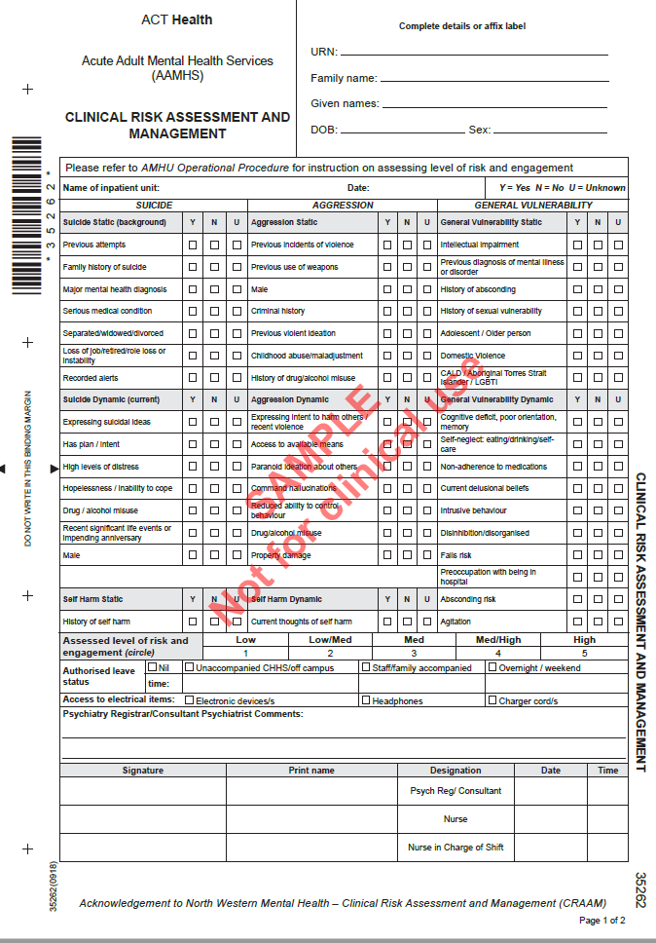

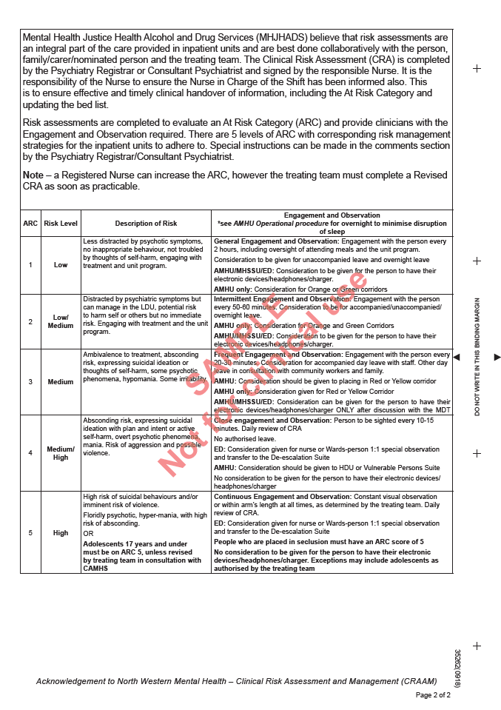

**Attachment 2 – Revised Clinical Risk Assessment and Management**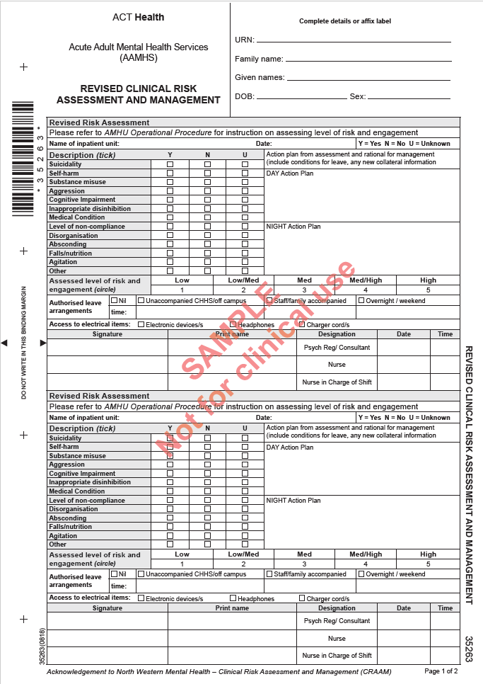

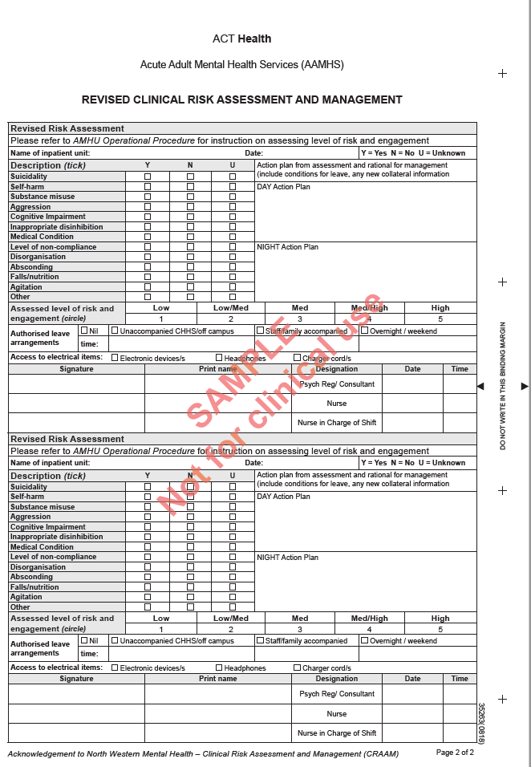

**Attachment 3 - Record of Observations Clinical Risk Re-Assessment**

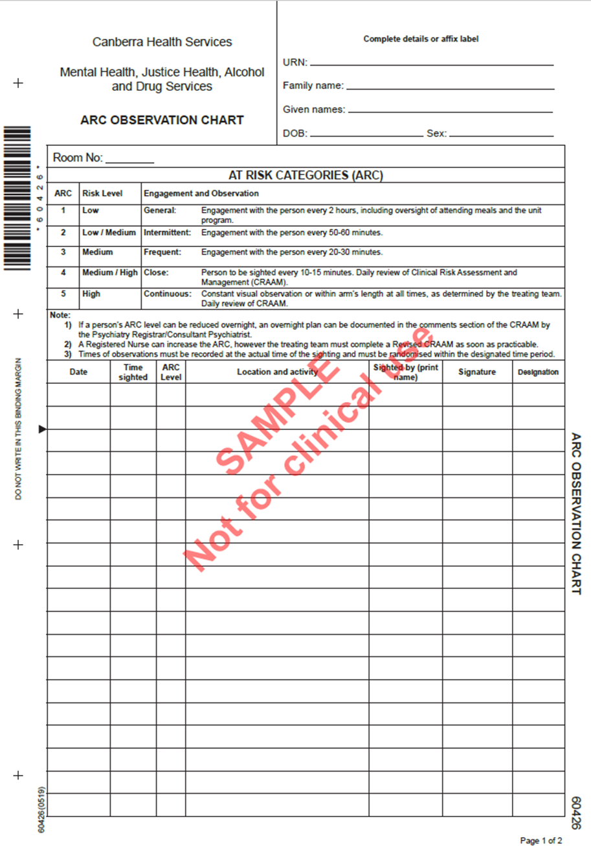

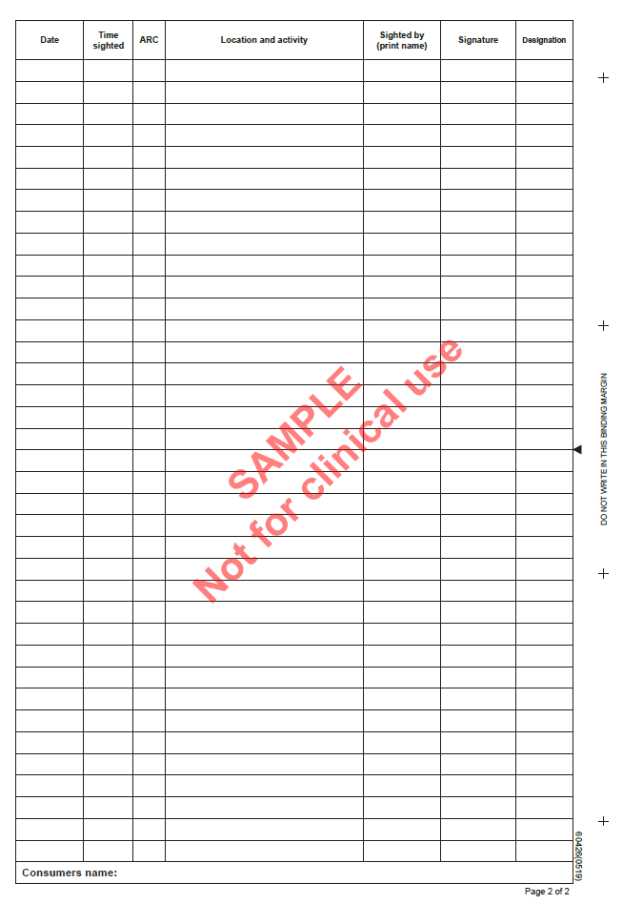

**Attachment 4 – Direct Admission to AAMHS at CHS Flowchart**



**Attachment 5 – AAMHS MDT Meeting Daily Agenda**

1. Territory Wide Bed Demand

* Emergency Department
* General medical beds
* Alexander Maconochie Centre (AMC)
* Direct admissions from CRS or External Health Facility
* Other

1. Handover of new admissions using ISBAR format

* Brief handover presenting problem
* Risk/ CRA ratified by the treating team
* Immediate needs identified
* EDD identified

1. HDU/LDU

* Issues and concerns including seclusion, restraint and forced medication administration
* Team by Team to escalate Nursing/medical/allied health issues
* Medication reviews / rewrites
* MH Act or s309 reviews
* Incidents of seclusion
* Incidents of physical restraint
* Incidents of forced medication administration

1. Bed flow/Leave/EDD

* Movement out of in and out of HDU
* The leave status for all admitted people including weekend leave and overnight leave planning
* Identified discharges
* Review of EDD

1. Other issues or incidents

* Staffing issues including compliance with nursing ratios

**Attachment 6 – Scanning Search including use of the Hand Held Metal Detector (HHMD) and Ordinary Search Information Sheet**

The Hand Held Metal Detector (HHMD) is used to detect the presence of metals close to or on the person being screened. It can indicate the presence of metal using sound, by vibration and by light-emitting diode. A Scanning search is to be:

* Undertaken prior to a room search, not routinely in front of other people.
* Undertaken by a person of the same sex as the person or a sex nominated by the person.
* With a minimum of two authorised people present utilising appropriate Personal Protective Equipment (PPE).
* Conducted in addition to routine room searching if an authorised person has a suspicion on reasonable grounds that the person is carrying a prohibited item or an item that may pose a risk to the security or good order of the facility.
* Conducted prior to a pat down search and in conjunction with an ordinary search (that is after outer garments and pockets have been removed/ emptied).
* Recorded in the person’s electronic clinical record.

**Procedure**

* Explain to the person why the search is required and how it is to be conducted. You should keep in mind that the person may not be familiar with the procedure.
* Ask the person if they have any dangerous items or items that could be used in an escape in their possession and request these be handed over.
* Request that pockets are emptied and the person remove any over-garments (jacket, hat etc.) Conduct an ordinary search of the garments removed – visual and hand search of item.
* Hold the detector at close proximity to, but not touching, the person’s body and scan the full length of their back, front and sides. Ensure the HHMD does not touch the person’s body.

| **Pay particular attention to areas commonly used for concealment, such as:** | **Provided below is a process that may help you to ensure you have completed a thorough scan. Commence scan at the left side of neck then:** |
| --- | --- |
| * pockets (including any inner jacket pockets) * lower-back region * waist, belt and belt buckle * underarms * wrists * foot and ankle areas * underneath headwear (for example, underneath hats or turbans) * hair * footwear * groin * chest | * sweep left front shoulder, down left front torso and left front leg * repeat on other side * double-check central torso * down arm to wrist * wrist to underarm * down side of torso and leg to ankle * inside of left leg * inside of right leg * up leg and side torso to underarm * underarm to wrist * wrist to neck and finish right side * sweep across front of body, from wrist to wrist * Repeat the same process on back of torso and legs. |

**Note**: Always remain balanced so as to avoid contacting the consumer. Carefully observe the consumer being screened. Keep alert for any sudden movements.

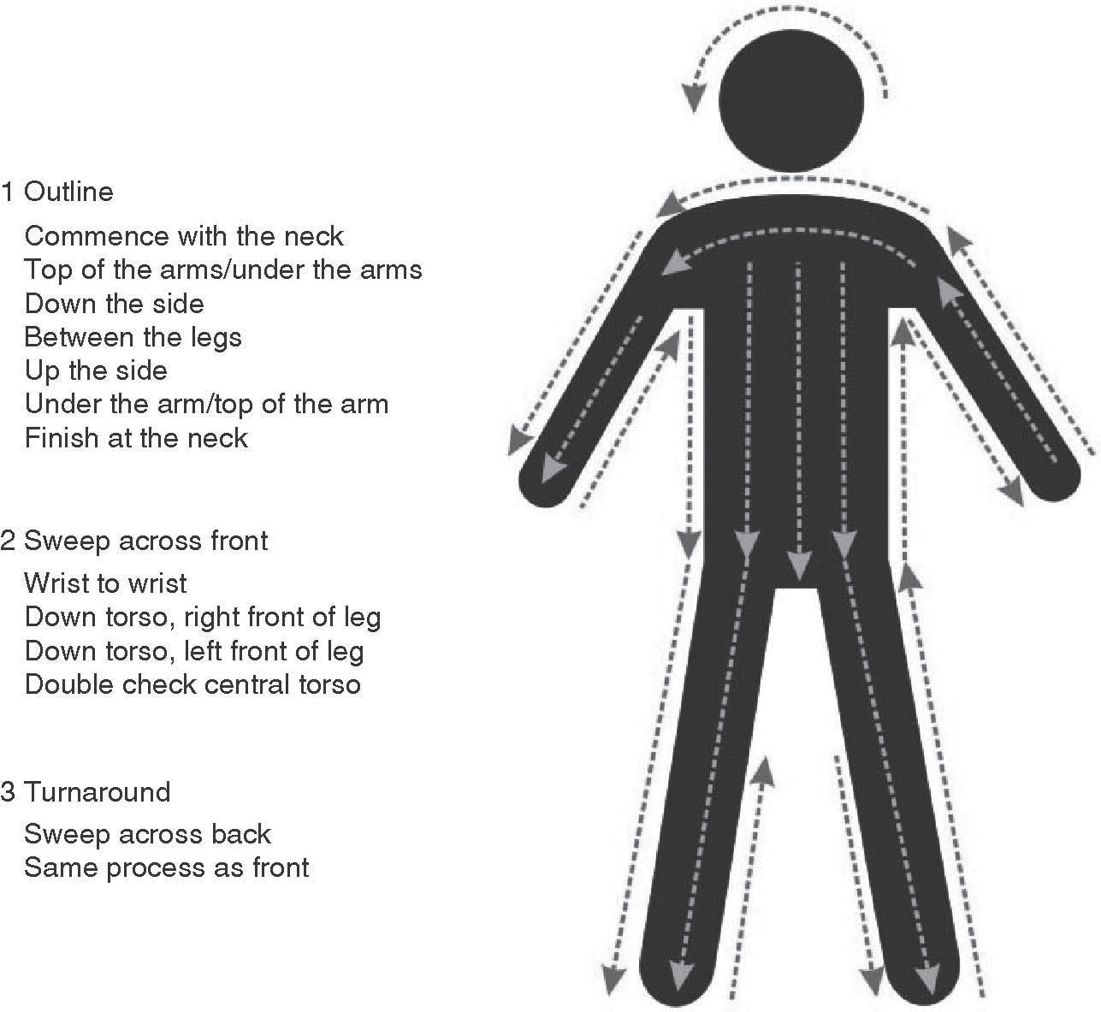

When screening the foot and ankle areas, you should take note of any readings from the detector caused by metal in the floor. To avoid this from happening, you can use the ‘low sensitivity button’ or ask the person to sit in a plastic chair with their feet either raised or placed on a wooden block or bench (one foot at a time). You should pay particular attention to boots, platform soles and high heels.

If the HHMD alarms during the screening procedure, you must identify the source of the alarm and ask the consumer to remove the item (ordinary search). These items should be physically search and you must scan the area on the person a second time.

Testing the HHMD

It is part of the role of Security Officer to conduct tests of the HHMD equipment.

The HHMD must be tested daily and before every use.

To test the HHMD, place it in close proximity to a metal object.

The HHMD will pass the test if it alarms. If the HHMD does not alarm, the test has failed.

The HHMD must not be used until the fault has been fixed and a test has been passed.

A Secondary Device is available whilst repairs are facilitated to the HHMD.

**Attachment 7 – Pat Down Search Information Sheet**

**Pat down searches are** to be undertaken by a member of staff of the same sex as the person and witnessed by a second member of staff.

A minimum of two authorised people are required to be present to conduct a pat down search. Personal Protective Equipment (PPE) must be utilised.

All pat down searches must be recorded in the person’s electronic clinical record. Prior to a pat down search a scanning and ordinary search of items removed including headwear, jackets and contents of pockets should be conducted.

If religious headwear is to be removed i.e. scanning search sounds an alarm or concern exists the consumer is concealing an item, ensure privacy

**Procedure**

* Provide reassurance to the person and maintain good communications throughout the procedure. Conduct with confidence. This is an intrusive search and such close proximity poses inherent risks.
* Request person to surrender any items that would present a danger to anyone in AMHU or may be used by a person to escape from AMHU they may have on their person. The person’s consent should be sought before a search is undertaken.
* Prior to a pat down search an ordinary search is to be undertaken, including shoes and socks. All items to be removed from pockets (these may be checked by a second member of staff).
* Person to be asked to stand with legs apart, arms outstretched and raised to shoulder height.
* Staff are to observe person’s facial expression and to be alert to verbal or non-verbal cues of apprehension or anxiety. Provide reassurance as necessary.
* Lift outer garment collar and ﬁrmly but carefully, feel around it. Move out from collar to shoulder area, then using both hands, check each arm in turn, rubbing down from armpit and shoulder to wrist. Remember to check the cuffs and ensure that person’s hands are empty.
* Ask the person to raise their outstretched arms to shoulder level (model if required); place both your arms around the person with the ﬁngers of both hands meeting at the person’s collar, pat down the back to the waist. Then rub your hands down the person’s sides and front. (NB. with females, do not run your hands over the breasts but pat down the area below breasts to waist).
* Inspect waistband and belt by pressing with ﬁngers either side of the waistband.
* Check lower half of body by placing both hands around each leg in turn, and rubbing down from waist to ankle remembering to check hems and turn-ups of trousers. For females wearing skirts or dresses, check each leg over the dress and then the hems. Hands should never be placed under the skirt or dress.
* Whilst it is difficult to discover small items during a pat down search, large, bulky items or small items carelessly concealed, should always be found. If you have any doubts or suspicions during or after completing a pat down search, inform the nurse in charge, or other senior staff member remembering not to leave the consumer unobserved.

**Person refuses to consent**

* If consent is refused, but the person authorised to search believes that there are grounds to proceed; authorisation to proceed must be sought from the Clinical Director, AAMHS; Operational Director, AAMHS; Consultant Psychiatrist; ADON; Consultant Psychiatrist on call (after hours) or the NIC.
* If a person refuses to co-operate with a pat down search he/she should be kept under constant observation and isolated from other people in either the seclusion area or their bedroom if this is in use. The NIC of the unit is to be informed (if they are not on their unit they should be returned to their unit under separate escort.)
* The person should be informed about why the search is required in terms appropriate to his/her understanding.
* People are not to avoid routine searches by refusing to co-operate.
* Documentation is required in the person’s ECR.

**Attachment 8 – MHJHADS Physical Exam and Investigations Form**